# RLCES_Logo2EO-LogoTag-Eng_BW_revEO-LogoTag-Fr_BW_rev

# P.O. Box 223 / 146 Howey Street Red Lake, ON P0V 2M0

[**www.redlakejobs.ca**](http://www.redlakejobs@shaw.ca) **/** [**redlakejobs@shaw.ca**](mailto:redlakejobs@shaw.ca)

Tel: (807) 727-2297 / Fax: (807) 727-1176

# Job Postings for the Red Lake/Ear Falls area

**September 27th, 2022**

**RED LAKE MEMORIAL HOSPITAL:** 

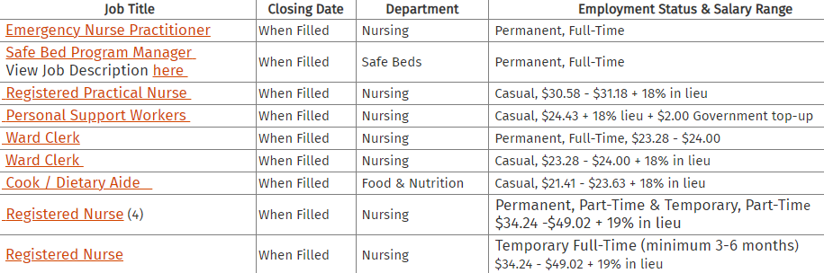Please click on the job title for more information, including salary information.

**Visit the Hospitals website for updated information:** [**Hospital Jobs**](https://www.redlakehospital.ca/currentopportunities)

**BEE CLEAN:**

Commercial cleaner required in Red Lake. Cleaning duties consist of sweeping and mopping floors, vacuuming, dusting, cleaning interior windows, cleaning washrooms, emptying garbage and other tasks as required. Various hours a week but site may require evening work after business is closed.

Experience preferred but will train the right candidate. A driver's licence and the ability to pass a criminal background check are definite assets. This position is available immediately.

Job Types: Full-time, Part-time Salary: $20.00 per hour

**See Indeed or Wow Jobs Ads to apply**

**STRATUS (WOC) INC. NEW\*\*\***

Weather Observer

Requirements:

* Minimum Grade 12
* Own reliable vehicle
* Basic computer skills
* Proficient Math Skills

Successful candidates will complete a NavCanada Training course in Cornwall, Ontario.

Training starts Oct 31st- Dec 9th. Transportation, accommodation and meals included.

Upon successful completion of the course, wages begin.

Forward resumes via email to: [stratuswocinc@shaw.ca](mailto:stratuswocinc@shaw.ca) or fax to: 1 780-414-1176

Preference will be given to already trained observers. Applicants taking the course will be requested to commit to a minimum of one year past training end date.

**RED LAKE TAXI:**

**2 Drivers**

Drivers available for Thursday, Friday, Saturday and Sunday Days 5am-3pm or Evenings 3pm-3am; some on-call; % of daily fares;

You must have: A clean drivers record, be 25+ years old, and have a full G licence

You must be able to obtain: vulnerable sector check, drivers abstract, taxi driver licence that’s obtained from the town after Vulnerable sectors check has been completed.

Must have good people skills and be able to assist customers with loading and unloading items.

**Send resumes to** [**redlaketaxi7272100@hotmail.com**](mailto:redlaketaxi7272100@hotmail.com)

**Contact Mike 728-1311 for more information about the positions available**

**WASAYA:**

* **Ramp Agent/ Bag Handler**
* **Aircraft Loader**
* **Loadmaster**

For more information visit: [Wasaya Airways LP :: Careers](https://www.wasaya.com/careers/)

**Application may be faxed to (807) 789-1645**

**or emailed to** [**careers@wasaya.com**](mailto:careers@wasaya.com)

**SCOTIABANK NEW\*\*\***

Senior Financial Advisor

Senior Customer Experience Associate, Part-Time

To apply visit company website: [Red Lake - Scotiabank Jobs](https://jobs.scotiabank.com/search/?createNewAlert=false&q=&locationsearch=red+lake)

**RED LAKE CAREER & EMPLOYMENT SERVICES:**

**Employment Adviser**

* Full-time; permanent; wage dependent on background and experience; group benefits; pension; great working environment!

Responsibilities:

* Provide client service to job seekers, in the form of clarifying employment needs, and job search assistance.
* Administrative duties pertaining to documentation, file maintenance, and statistical reporting: proficient with Microsoft Office applications, database and Internet.
* Marketing of programs to area employers, potential job seekers, and community at large.
* Workshop presentations to various client groups.

Knowledge, Skills & Abilities:

* Office administrative procedures and ability to maintain a high level of accuracy, with attention to detail.
* Adhere to strict candidate and employer confidentiality.
* Demonstrated excellent interpersonal skills.
* Demonstrated team building skills.
* Demonstrated effective analytical and problem solving.
* Effective verbal, written and listening communication skills.
* Time management skills.
* Must be honest, and trustworthy.
* Possess cultural awareness and capability.
* Demonstrate sound work ethics.

Qualifications:

* Related post-secondary education (i.e. Employment Counselling, Career Development, Social Work).
* Demonstrated knowledge and understanding of employment and training sector.
* Demonstrated knowledge and understanding of challenges faced by Northern Ontario job seekers.
* Clear Criminal Background Check and Vulnerable Sector Screening required.
* Must have valid driver’s license and access to a vehicle.

**Submit resume and cover letter by Friday October 7th to:**

Sandra Marshall, Director

Red Lake Career & Employment Services

P.O. Box 223 / 146 Howey Street

Red Lake, ON P0V 2M0

e-mail: [redlakejobs@shaw.ca](mailto:redlakejobs@shaw.ca) / Fax: (807) 727-1176 / Tel: (807) 727-2297

*We will make available accommodations for job applicants who have disabilities. Accommodations for people with disabilities are available on request for interviews and selection processes.*

*This Employment Ontario program is funded in part by the Government of Canada and the Government of Ontario, and sponsored locally by Red Lake Margaret Cochenour Memorial Hospital.*

**ADULT LEARNING CENTRE 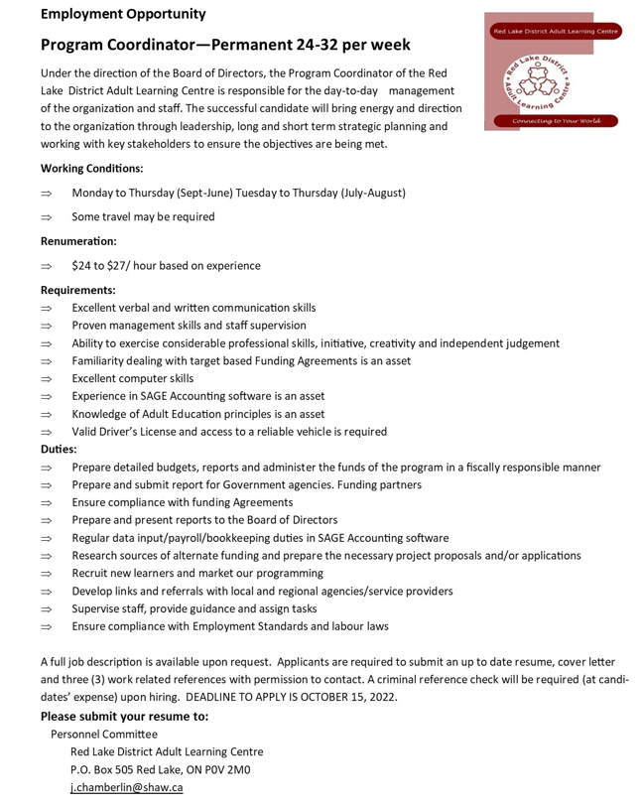**

**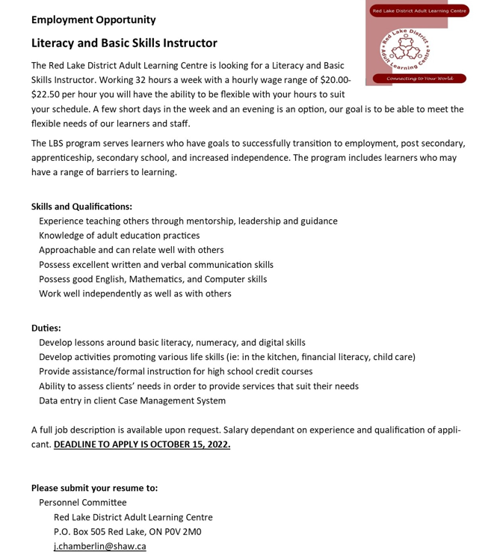**

**RED LAKE MUNICIPALITY**

**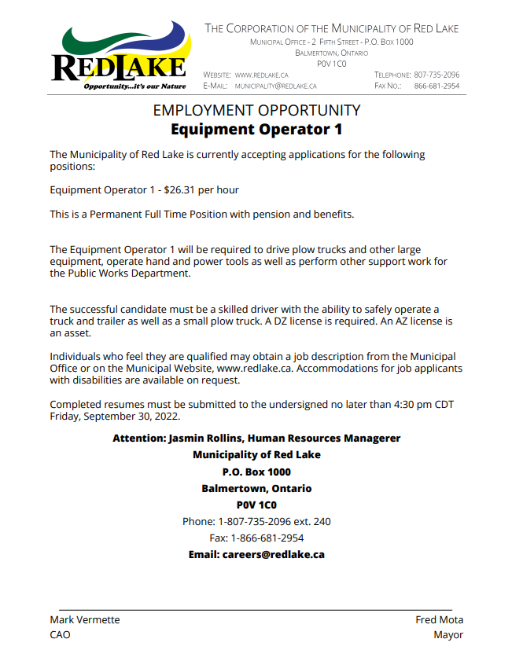**

**Arena Helper/Rink Rat – $14.60 an hour (student Position)**

This is a casual student employment position; employees will perform call in work throughout the week. Duties Include:

- Report unsafe conditions within and around the skating rink to ensure safe use by public.  
- Garbage pick up in and around the building.  
- Assist with maintenance of the ice surface (moving nets for flooding and assisting attendant with maintenance).  
- Cleaning of dressing rooms, lobby, stands, etc.  
- Perform other duties as assigned by the Facility Attendant.  
- Applicants must be at least 14 years of age.

Individuals who feel they are qualified may submit a completed resume to the undersigned no later than 4:30 p.m., Friday, September 30th, 2022

**FAST AIR:**

**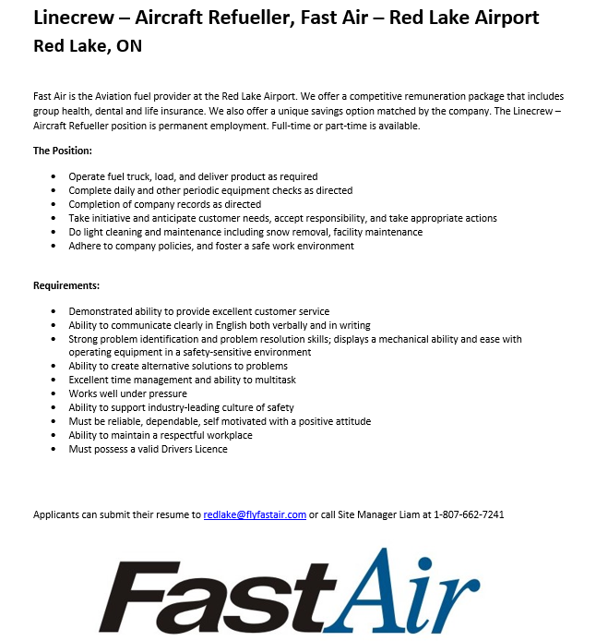**

**KINROSS:**

**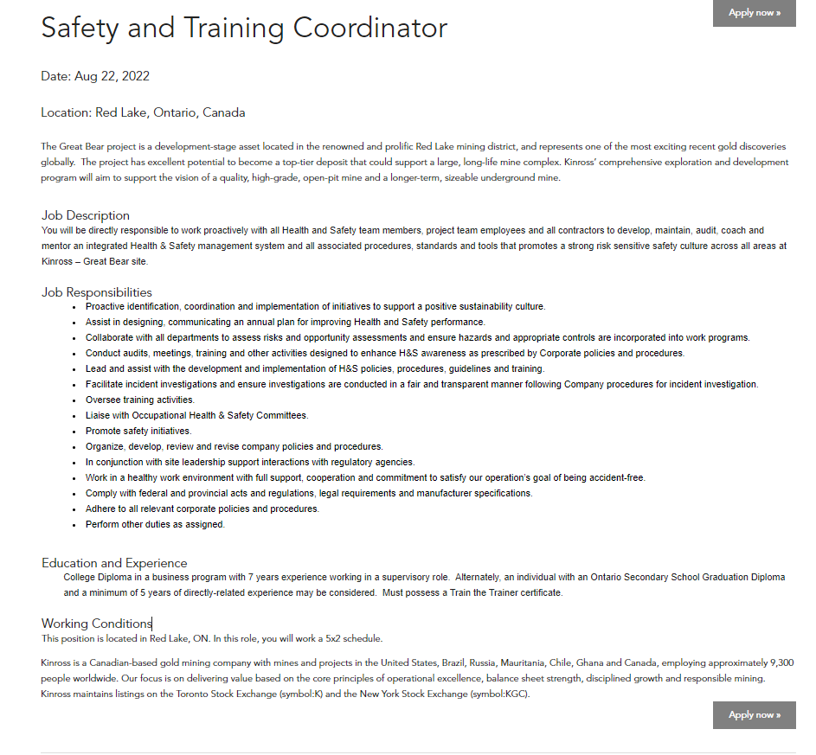**

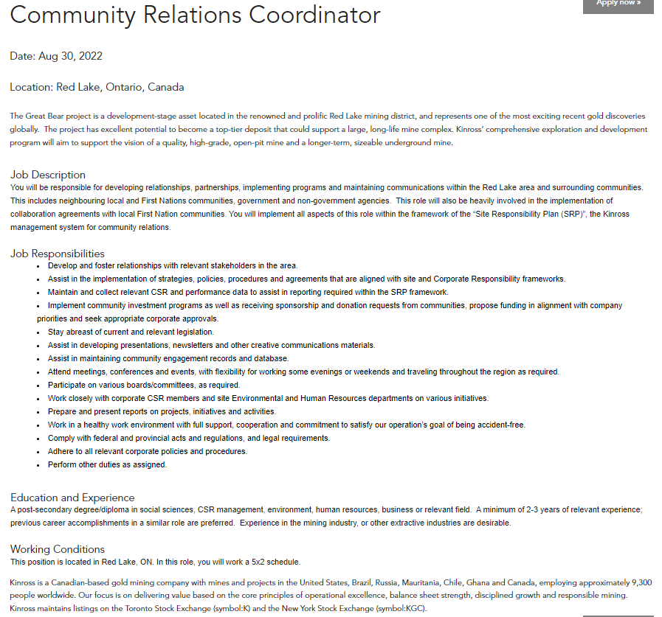

**To apply visit:** [Red Lake - Kinross Gold Corporation Jobs](https://jobs.kinross.com/search/?createNewAlert=false&q=&locationsearch=red+lake)

**GREEN ACRES CONTRACTING NEW\*\*\***

* Truck and Coach Mechanic
* Heavy Duty Mechanic
* Automotive Mechanic
* Skidder Operator
* Road Side Processor Operator
* Buncher Operator

\*Great Wages, full time hours with benefits\*

If you're interested in a position, please email resume

[**kirk\_241@hotmail.com**](mailto:kirk_241@hotmail.com) **/** [**greenacrescontracting@yahoo.ca**](mailto:greenacrescontracting@yahoo.ca)

or call **807-727-7592** for more information

**TIM HORTONS:**

**Food Service Supervisor**

* Permanent Full-time $16 an hour 30-40 hours weekly
* Benefits: Health benefits and long term

To apply: email [fss@ajccanada.com](mailto:fss@ajccanada.com), in-person, by mail 5 Hughes Cr. Red Lake ON P0V 2M0

Include reference number 2011533 in your application

BOART LONGYEAR:

* Long-hole Driller
* Administrative clerk

Please apply via email at [ela.macburnie@boartlongyear.com](mailto:ela.macburnie@boartlongyear.com)

**GARDEWINE**

**A/Z City P&D Driver**

**All jobs in Red Lake, ON | WowJobs**

**HARMONY CENTRE FOR COMMUNITY LIVING**

**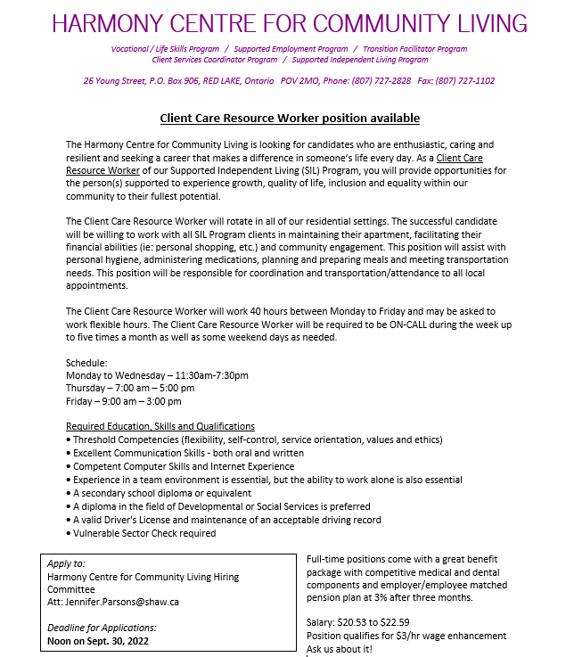**

**KEEWAYTINOOK OKIMAKANAK** 

**Community Engagement and Education Program Coordinator**

**SUMMARY**

Reporting to the Assistant Director of KO eHealth and Telemedicine Services (KOeTS), the Community Engagement and Education Program Coordinator develops the framework that supports a distance format continuing education and professional development program for community health workers in First Nations communities. The Education Program Coordinator also supports community health workers to provide healthy lifestyles oriented and culturally appropriate educational sessions of relevance to community members.

The Community Education Program Coordinator works closely with community health workers and organizations to identify their health education and training priorities and to identify the healthy lifestyles educational interests of community members. S/he develops strategies to address these priorities and secures presenters to host these telemedicine educational sessions. S/he then evaluates the sessions to ensure they have addressed the participants’ needs.

The Community Engagement and Education Program Coordinator documents the KO eHealth education strategies for application to other First Nations health regions.

In addition, S/He develops and supports KOeTS community engagement activities and will ensure that engagement functions and resources are effectively integrated, organized and leveraged to meet strategic and operational needs of KOeTS

**RESPONSIBILITIES**

**1. Coordinates the development of regional telemedicine educational programming**

1. a) Researches and stays current on the educational needs of community health workers in First Nations (e.g., Health Directors, CHRs, health program coordinators, home and community care workers, etc) by designing and implementing a needs assessment strategy

b) Works with Community Telemedicine Coordinators (CTCs) and community health

stakeholders to identify First Nations community members’ healthy lifestyle

interests for local ehealth education program development

c) Interprets community members’ healthy lifestyle interests holistically, incorporating

physical, mental, emotional, and spiritual educational elements in program

development

d) Develops, coordinates, and implements a culturally appropriate, holistic, and

sustainable model of delivery for distance education and training programs relevant

to First Nations community members and community health workers’ needs

e) Secures presenters/educators to deliver programs identified as priorities

f) Works with the Clinical Schedulers, CTCs and CTC supervisor to advertise

upcoming educational events

g) Produces an advance calendar monthly to advertise upcoming educational events

2. Analyzes and reports on educational program relevancy

a) Compiles and analyzes participant evaluations from each educational session and

compares responses with program objectives

b) Maintains ongoing contact with the communities, including site visits, to ensure the

relevance of educational programming and explore potentials for program expansion

c) Gathers statistics to produce quarterly reports for the Director of eHealth Services

that document and analyze achievements and challenges with strategies for

addressing problems and future program development plans

d) Documents KO eHealth education strategies for application to other First Nations

health regions

3. Coordinates social animation activities on the network

a) Coordinates events and activities that enrich the social and cultural fabric of First

Nations communities, e.g. Elders gatherings, music festivals

b) Books regional videoconference forums and roundtables as requested

c) Looks for other opportunities to utilize KO eHealth networks in a socially cohesive

capacity

5. Community Engagement Coordinator Role

a) Develop and support community engagement strategy involving KOeTS affiliated

communities

b) Participate in health engagement activities of KOeTS affiliated communities

c) Organize community engagement activities that are integrated with identified health

priorities and align with KOeTS strategy

d) Identify communication opportunities and develop material in collaboration with

KOeTS team.

e) Assist in the rollout of communications materials to KOeTS affiliated communities

working in collaboration with KOeTS team.

f) Manage and oversee KOeTS social media accounts

6. Demonstrates commitment to KOeTS team

a) Participates in KO eHealth staff meetings and on committees as required

b) Participates in annual performance evaluation as required

c) Works collaboratively with KO eHealth management and Community Telemedicine

Coordinators to ensure high quality telemedicine service delivery

d) Participates in training and updating activities to maintain knowledge and skill level

as per goals set during annual performance appraisal

e) Other duties as assigned by Assistant Director of eHealth Services

**KNOWLEDGE, SKILLS, AND ABILITIES**

a) College diploma or university degree in health, education or social services or

equivalent working experience in the education field

b) Minimum three years experience working with First Nations communities in health

or education

c) Knowledge and understanding of Aboriginal culture and values, and of the

geographical and health care challenges of First Nations in the Sioux Lookout

district

d) Ability to speak Cree, Oji-Cree, v or Ojibway a strong asset

e) Familiarity with health system in the district

f) Experience in health program planning for First Nations communities

g) Knowledge of adult learning and training strategies

h) Strong oral and written communication skills

i) Strong computer and communications technology skills; competence in a database

program(s) and video conference network systems preferred

j) Frequent travel to remote communities required

Location: Balmertown, Ontario - Full Time Permanent

Apply at <http://www.kochiefs.ca>

**RED APPLE STORES**

**Assistant Store Manager**

You will be responsible for the performance and management of the store, including meeting and exceding sales and other financial targets. You will ensure proper executionof customer service and merchandising standards, policies and procedures, and Associate development.

Additional Responsibilities:

* Overall responsibility for sales and profitability of the store
* Control expenses and manage customer relations
* Ensure customer service practices are implemented
* Ensure basic merchandise is filled and resolve out of stocks
* Follow all merchandise and display pricing guidelines
* Recruit, train, develop, motivate and manage associates
* Recover store on a daily basis
* Set up ads properly and on time
* Receive daily/weekly freight truck
* Manage all administration
* Ensure all loss prevention policies and procedures are followed

Knowledge/Experience:

* 1-2 years management experience
* Grade 12 education or equivilant
* POS experience
* Career minded, a self starter, and custpmer oriented
* Strong communication, organizational, leadership, decision making, and interpersonal skills
* Flexible, super friendly, courteous, adaptable, efficent and professional manner

Red Apple Stores ULC provides employment accomodation during the recruitment process. If you are an individual with a disability and need assistance completing your application, please contact HR at [hrdept@redapplestores.com](mailto:hrdept@redapplestores.com)

All applicants please email your resume directly to [hrdept@redapplestores.com](mailto:hrdept@redapplestores.com)

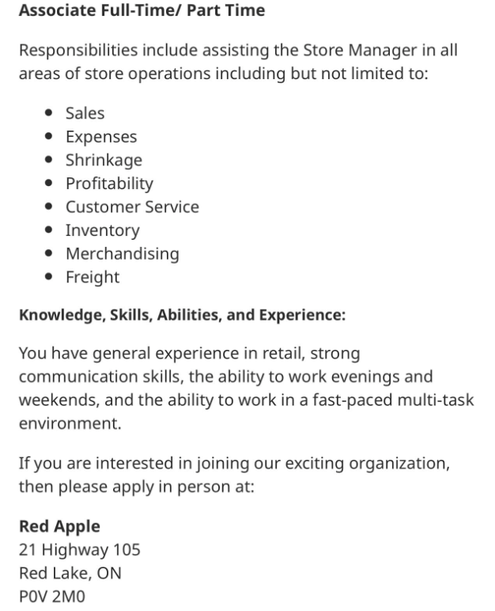

**RED LAKE PLUMBING AND HEATING**

**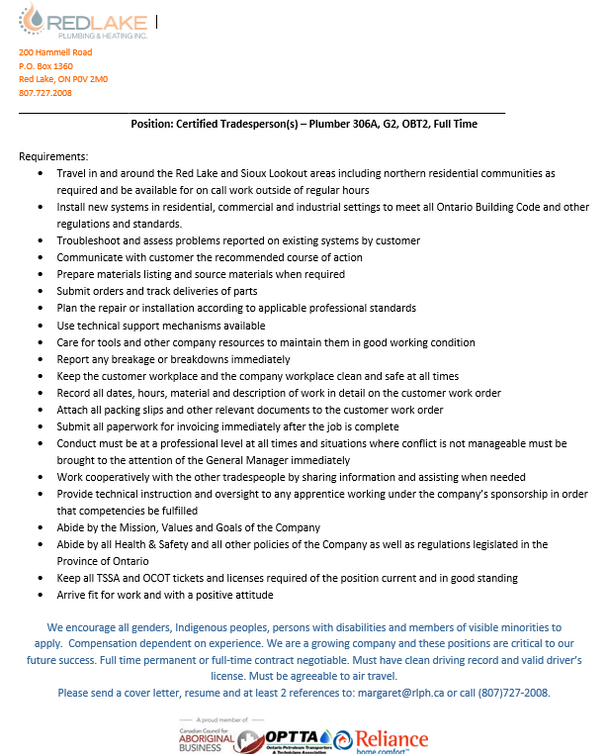**

**RED LAKE PLUMBING & HEATING  
General Labourer - Full Time, 40 hours per week**

**Requirements:**

* Travel in and around the Red Lake and Sioux Lookout areas including northern residential communities as required and be available for on call work outside of regular hours.
* In town work at construction sites and other commercial buildings
* Package parts, materials and tools and move them to jobsites. Move/lift hot water tanks, furnaces and sewer equipment into place.
* Set up piping, fittings and ducting under the direct supervision of the certified tradesperson.
* Assisting with running sewer cleaning equipment and thawing equipment.
* Clean jobsites and shop areas.
* Keep accurate records with respect to timesheets and other relevant documentation.
* Maintain vehicles and equipment used in good condition.
* Lifting, digging and all other manual labour required in construction
* Must be able to work outdoors in all weather conditions
* Conduct must be at a professional level at all times and situations where conflict is not manageable must be brought to the attention of the General Manager immediately
* Abide by the Mission, Values and Goals of the Company
* Abide by all Health & Safety and all other policies of the Company as well as regulations legislated in the Province of Ontario
* Arrive fit for work and with a positive attitude

We encourage all genders, Indigenous peoples, persons with disabilities and members of visible minorities to apply. Full time permanent or full-time contract negotiable. Must have clean driving record and valid driver’s license. Must be agreeable to air travel.

Please send a cover letter, resume and at least 2 references to:  [margaret@rlph.ca](mailto:%20margaret@rlph.ca) or call

(807)727-2008.

**BALMER HOTEL: UPDATED\*\*\***

* **Cook**
* **Food Service Supervisor**
* **Hotel Cleaner**

**To apply please email your resume to:** [balmerhotel@hotmail.com](mailto:balmerhotel@hotmail.com)

**HOME HARDWARE:**

**Delivery Driver (Full-Time)**

* Loading, transporting, and delivering items to customers in a safe, timely manner
* Review order before and after delivery to ensure orders are complete and the customer is satisfied
* Assist with loading and unloading product from vehicles and delivery trucks
* Provide excellent customer service, answer questions, and handle customer complaints
* Abide by all transportation laws and maintaining a safe driving record
* Prepare packing slips, reports, and other documents relating to deliveries
* Operate forklifts, hand trucks, trucks, cars, etc. for deliveries and product movement

**Qualifications for Delivery Driver**

* High school diploma or equivalent
* Valid driver’s license
* Clean driving record
* Delivery driver experience recommended
* Willingness to adhere to assigned deliveries, schedules, safety procedures, and transportation laws
* Ability to work independently and on a team
* Very detail oriented and good navigational skills
* Strong time management and customer service skills
* Ability to walk, drive, lift, and carry heavy items

**Estimator**

* Analyze labor, material, and time requirements for a project
* Estimate costs by looking at the entire project
* Present cost estimates to customers
* Prepare quotes detailing all of the costs going into a project
* Look at customer requirements for a project
* Work with the sales team to prepare proposals

**Qualifications**

* 1-2 years of experience working as an estimator and/or in construction
* Ability to work independently
* Ability to work well on a team
* Very detail oriented and good math skills
* Ability to understand technical drawings and requirements

**Hardware Associate**

* Work with team in maintaining presentation of sales floor keeping product organized and stocked
* Receive, store, and work all incoming product to the sales floor
* Provide exceptional customer service with product knowledge and a proactive attitude to meet customer needs and provide solutions
* Develop a rapport with contractors
* Greet customers warmly and offer assistance with products and services
* Assist customers with finding products needed, mix paint, cut keys, stock shelves, price changes, and organize sales
* Assist in daily sales goals, answer phones, set up and sell special orders, and pick orders for shipment

**Qualifications for Hardware Associate**

* Retail experience, Hardware and construction experience recommended, Cheerful and friendly demeanor, Ability to lift 20+ lbs, Ability to work independently and in a team & Willingness to learn

**Shipper/Receiver**

* Move merchandise in warehouse and in-store
* Determine method of shipment and arrange shipping or delivery
* Prepare bills of lading, invoices, and other shipping documents
* Obtain payment for orders before sending out
* Assemble orders and label for shipping
* Receive shipments from Home Hardware and other suppliers
* Inspect and verify shipments against Purchase Orders bills of lading
* Unpack, program, and send product to appropriate areas
* Maintain inventory
* May operate forklift, hand truck, or other equipment to load, unload, transport, and store products

**Qualifications for Shipper/Receiver**

* 1-2 years as shipper/receiver or warehouse experience
* Ability to work independently
* Ability to work well on a team
* Detail oriented and meticulous
* Ability to lift 40 lbs or more
* Hardware and construction experience recommended

**Apply in person and ask for Ruth or email your resume to** [**ruth.gaucher@homehardware.ca**](mailto:ruth.gaucher@homehardware.ca)

**KENORA DISTRICT SERVICES BOARD: **

* [***One (1) Temporary, Part-Time Registered ECE/ECE Assistant – Red Lake (10 hours/week for our Before-School Program)***](https://kdsb.on.ca/jobs/one-1-temporary-part-time-registered-ece-ece-assistant-red-lake-10-hours-week-for-our-before-school-program/)
* [***One (1) Temporary, Part-Time Registered ECE/ECE Assistant – Red Lake (15 hours/week for our After-School Program)***](https://kdsb.on.ca/jobs/one-1-temporary-part-time-registered-ece-ece-assistant-red-lake-15-hours-week-for-our-after-school-program/)
* [***Temporary, Part-Time Weekend Day Shift Shelter Attendant – Red Lake***](https://kdsb.on.ca/jobs/temporary-part-time-weekend-day-shift-shelter-attendant-red-lake/)
* [***One (1) Temporary, Full-Time EarlyON Child and Family Centre Coordinator – Red Lake***](https://kdsb.on.ca/jobs/one-1-temporary-full-time-earlyon-child-and-family-centre-coordinator-red-lake/)
* [***Permanent, Full-Time, Registered ECEs or ECE Assistants – Red Lake***](https://kdsb.on.ca/jobs/permanent-full-time-registered-eces-or-ece-assistants-red-lake/)
* [***Casual Registered ECEs/ECE Assistants – Red Lake***](https://kdsb.on.ca/jobs/casual-registered-eces-ece-assistants-red-lake/)
* ***Temporary, Part-Time, Registered Early Childhood Educator (Registered ECE) or Early Childhood Educator Assistant – EY22-42***

**\*\*\*Please click the link below or click a specific job post to see full job descriptions for positions at KDSB:** [**https://kdsb.on.ca/join-our-team/**](https://kdsb.on.ca/join-our-team/)

****BYRNECUT CANADA LTD**

****

|  |
| --- |
|  |

**NORTHERN WATERWORKS Inc.**

**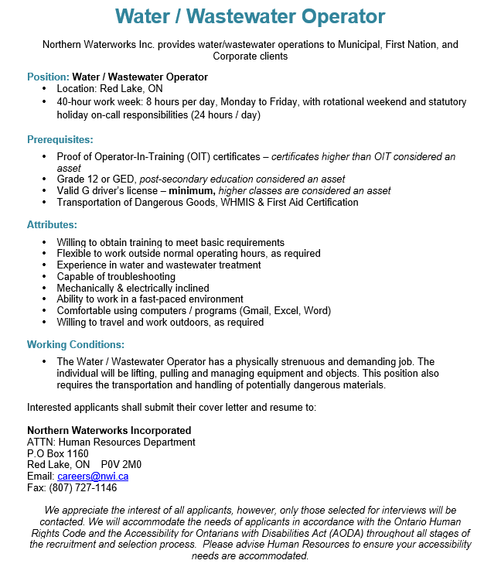**

**MONCRIEF CONSTRUCTION LTD**

MCL is looking to hire **Flaggers and Labourer's**

**Responsibilities**

· Stop, slow, and safely direct traffic through construction sites and work zones

· Operate handheld radios to communicate with crew

· Willingness to work outdoors in all weather conditions and be fit to work.

· Works safely around heavy construction equipment and travelling public

· Experience setting up and taking down traffic control equipment

**Knowledge & Skills**

· Traffic Control Person Training (MCL can provide this training)

· The ability to work with others in a team

· Must be willing to work in remote job locations

· Repetitive movement

· Able to perform in a fast-paced environment

· Continuously changing work tasks

· Ability to work and stand a significant number of hours throughout the day

· Ability to work in all weather conditions and environments

Job Types: Full-time, Seasonal

Salary: $22.00 per hour

Schedule:

* 10 hour shift, 12 hour shift, 8 hour shift
* Red Lake, ON: reliably commute or plan to relocate before starting work (required)
* Secondary School (preferred)
* construction: 2 years (preferred)
* Drivers Licence (preferred)

**To apply visit:** [Flaggers/ Labourers-Red Lake/ Ear Falls Ontario Area - Red Lake, ON - Indeed.com](https://ca.indeed.com/viewjob?jk=8afb3512b7c3a751&q=+-loctype%3Acountry+-loctype%3Aregion&l=RED+LAKE%2C+ON&tk=1gcu3t016gpnd800&from=api&advn=3589315279130095&adid=397598611&ad=-6NYlbfkN0Dq6HTewCZP9Vjuyz7KQo52a_gSYyocQ9x9uYjQQe9EqBgQXRxxoXWPAhGwEVaV3JBllYzmzXpi2DcQQHHYE7YI1meAG5MBwTdXDVudMRbb8dXVrk0tcg3albhGPVnLuM711bFZIsJfjZz19D1aEid3yhqmRS2l1xl0Jxz_9H4k78wtUkGmRzDAOEP9c8Hk47CWsNVciWkOhzrSTRyYZkQliPL_8HcZQhGnRAiFRAV1pfYoyLWUb1Yxa3S-29Q0GWvvMh1T9irJiuCocZ5gbWiBrcc4rq2wUp-wzeXManiblafr-uzbY10qiGY4pk987v_-V1BvDNOC0tpZjOU-KGiq-s7wsEpzt40zrwd5DjWWvPa6JvCe2svT1jXOTkmN_KsSdNN7Dxd6rjz7mYBdbJstXt70TNS7f20%3D&pub=2b840b5ededf393bc74afbdf872c24260cace3277f6b99df&xkcb=SoBn-_M3ZeP72V_Y5B0PbzkdCdPP)

**SUPER 8:**

Super 8 Red Lake is looking to **hire 2 full time or part time housekeeping positions.**

Housekeeping staff is responsible for the cleanliness of the entire property.

Daily tasks will be assigned by the housekeeping supervisor/manager.

Daily tasks will include but not limited to:

1. Cleaning/preparing guest rooms for check in with the brand standard.

2. Vacuuming hallways, wiping down light fixtures

3. Sweeping/mopping lobby and other areas

4. Assisting front desk staff with meeting rooms set up, cleaning

5. Performing deep cleaning in guest rooms

6. Cleaning public restrooms

7. Washing, drying and folding linens and towels

Willing to train the right candidate and pay is negotiable.

**Guest Service Representative:** **Full time/ Part time**

Primary duties of guest service representative will include but not limited to:

- Providing friendly and courteous service to all patrons

- Answering phone calls to provide information about the property, availability, to process new reservations, update existing reservations and providing information about service and amenities offered

- Providing information about local attractions and businesses

- Processing payment accurately as per company policies

- Assisting guests with special requests

- Working closely with other departments to ensure smooth operation

- Keeping front office and lobby areas clean and tidy

- And any other tasks assigned by supervisor/Manager

Candidates must possess a friendly attitude who can multitask in a busy environment. Must also possess good phone etiquette, good communication skills, good computer skills. Flexibility to work both weekdays and weekends must.

Preference will be given to candidates with experience. However, willing to train the right candidate.

Starting pay will be $17.50. Pay can be negotiated for candidates with prior experience in the hotel industry.

Drop off the resume at Super 8 Red Lake or email to [barth.super8redlake@gmail.com](mailto:barth.super8redlake@gmail.com)

**NORTHWEST TIMBERMART:**

We are a Full-Service Lumber and building Center located in **Red Lake, Ontario**and looking to add a **CUSTOMER SERVICE REPRESENTATIVE** to our team! The Municipality is in the upper northwest corner of Ontario in the heart of Canada. Residents enjoy the area’s natural beauty, with pristine lakes, rivers, streams, forests and clear blue skies. The Red Lake area offers great fishing and hunting along with one of the best-kept ecotourism sites in the world - Woodland Caribou Provincial Park. We are a one-stop shop for all your home renovation needs. We specialise in kitchen/home improvement renovations, custom design buildings and Do It Yourself handy-person. We turn our customers ideas into reality with a “You can do anything” philosophy, so creativity, passion, and a meticulous attention to detail are essential qualities for this role.

**Responsibilities and Duties**

* Understand that our customers are our priority, and that we work to serve them
* Have good oral and written skills, including spelling, with strong critical thinking ability and problem solving
* Be highly organized, accurate and diligent with paperwork with strong attention to detail
* Be skilled with the use of computers
* Be able to prioritize multiple orders received and process them in a timely fashion
* Knowledge of lumber, plywood and other building materials is an asset
* Work well with others in a fast-paced environment
* Be able to lift up to 50 LBS
* Maintain an organised and clean shopping area and ensuring safety standards are upheld

**Qualifications and Skills**

Can you listen? Do you like physical work, without being a renovation pro? Do you have a knack for first-class customer service? Then you have what it takes to be in our team!

ASSET: experience in customer service, plus knowledge in our Lumber and Building Materials department.

The right attitude can go a long way... we will train the right person.

Full-time, Permanent, PART-TIME ALSO AVAILABLE, with part-time hours: 20-40 per week

Salary: $20.00-$22.00 per hour with benefits included

**To apply email: northwest@timbrmart.ca**

**EMCON SERVICES:**

* + General Laborer Seasonal
  + Winter Seasonal Maintenance Operator (3 openings)

**Please visit** [**EMCON**](https://www.emconservices.ca/jobs-ontario.html) **for more information and to apply.**

**WAREHOUSE ONE:**

**SALES ASSOCIATE/KEY HOLDER- Part-Time**

**Duties & Qualifications:**

Sales Associate/Key Holders with Warehouse One are responsible for confidently providing our customers with a shopping experience that is friendly, committed, caring, and real. They also lead shifts - providing coaching and direction to other members of the team to help them reach their goals.

**Requirements:**

• Ensuring that every customer receives outstanding service by providing a friendly environment, which includes greeting, acknowledging and re-approaching

• Driving Warehouse One brand loyalty through our Perks customer loyalty program

• Performing Point of sales transactions and merchandising tasks, such as receiving shipments of product and preparing it for the sales floor

• Creating and fostering a positive work environment

• Overseeing store operations, including shift task organization and store opening and closing duties, in conjunction with/or in the absence of management

• Ensuring the store is visually appealing through participation in product presentation, store housekeeping and visual displays

**WHO YOU ARE**

• Prior supervisory experience, preferably in a retail setting

• Sales driven and customer service focused with an eye for fashion and a drive to help customers find clothing they love

• Able to stand for extended periods, climb a ladder and to move and handle boxes of merchandise (weighing up to 30 pounds) and fixtures throughout the store

• Flexible in availability- able to work daytime, evening and weekend shifts

• You’re able to represent WHO WE ARE at Warehouse One; Friendly, Caring, Committed, Real

**SALES SUPERVISOR (Team Lead) Full-Time**

As a Team Lead with Warehouse One you collaborate with our store manager to lead our team and business, all while confidently providing our customers with a shopping experience that is friendly, committed, caring, and real.

**Team Lead Responsibilities:**

Assists in leading the team alongside the store manager or in their absence

Ensuring that every customer receives outstanding service by providing a friendly environment, which includes greeting, acknowledging and re-approaching

Driving Warehouse One brand loyalty through our Perks customer loyalty program

Creating and fostering a positive work environment where all team members are driven to meet and exceed store performance goals

Overseeing store operations, including shift task organization and store opening and closing duties

Performing Point of sales transactions and ensuring the store is visually appealing through participation in product presentation, store housekeeping and visual displays

**WHO YOU ARE**

Leaders who can support, motivate, and manage others

Eager to help Warehouse One customers and provide the best customer service

Fashionably Casual and enthusiastic about Warehouse One’s product and image

Flexible in their Availability; able to work days, evenings, and weekends to support customers and their fellow team members

Able to represent Warehouse One’s WHO WE ARE; Friendly, Caring, Committed, Real

Ideally, experienced in the fashion retail industry

To apply : <https://warehouse-one-the-jean-store.careerplug.com/jobs/1767924/apps/new>

or [hr@warehouseone.com](mailto:hr@warehouseone.com)

**KENORA CATHOLIC DISTRICT SCHOOL BOARD:**

**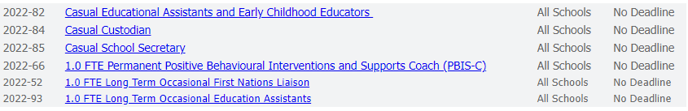**

**To see full job descriptions and how to apply visit the website:**

[Employment - Kenora Catholic District School Board (kcdsb.on.ca)](https://www.kcdsb.on.ca/our_board/leadership/services/human_resource_services/employment)

**WALSH CONTRACTING LTD. -** Carpenter

General Requirements:

1. Must have physical abilities to perform general construction work.

2. Special Construction work experience (Painting, roofing, drywall, framing, brushing, siding, misc. carpentry).

3. Ensure tasks are completed according to standards and expectations set forth by the scope of the contract.

4. Must have a vehicle and valid driver’s license.

Wage rate: Depending on the experience.

                   Minimum of $20.00 / hr. Seasonal job

**If interested kindly send your résumé to:** [**bewalsh@hotmail.ca**](mailto:bewalsh@hotmail.ca)

**IGA:**

* **Full- time meat cutter & Part-time meat cutter**
* **Part-time cashier (3)**
* **Part-time deli clerk & Part-time courtesy clerk**
* **Bakery Clerk Full-time & Part-time**
* **Part-time Cake Decorator**
* ***Contact Red Lake Career & Employment Services for full Job Descriptions!***

**KENORA RAINY RIVER DISTRICTS CHILD & FAMILY SERVICE**

**Casual Support Worker:**

* Adhere to the detailed supervised visit rules and expectations as outlined by the Child Welfare Worker.
* Observe and report findings in an objective and factual case note or log book format as applicable.
* Ensure the safety and well-being of clients at all times.
* Transport clients to and from visits and other appointments as required.
* Responsible for the daily care and direct supervision of children placed in a staffed resource unit.  
  **Hours of work:**Flexible, casual on call. **Wage Range:** $18.75 - $20.48 per hour.

**Knowledge and Skills Required:**

* Be familiar with and provide services in compliance with relevant legislation, ministry regulations and standards, and agency policies and procedures.
* Complete documentation in accordance with prescribed agency, ministry and legal standards.
* Provide consultation to and work with other staff, agencies and professionals in the provision of services to children and their families.
* Excellent verbal and written communication and problem-solving skills are required.
* Demonstrated ability to follow direction, work independently and as a member of a team.
* Ability to relate well to children and families as a mature and responsible adult role model.
* Good judgement skills and ability to work in stressful, high-pressure situations.
* Proficient in computer software applications including MS Office, and database programs.

**Qualifications:**

* Minimum high school diploma or equivalency required.
* Experience as a caregiver and/or formal child care training.
* Nonviolent crisis intervention training and First Aid CPR would be an asset.

**Child Welfare Worker for Full Time Position (Quote File #24/22)**  
**Position Summary:**

The Child Welfare Worker is responsible for the provision of a broad range of child welfare services including intake, assessment, and clinical intervention with children and their families. They will be required to conduct investigations, provide emergency services, make applications to the court and ensure that the needs of the children living either in their own home or in care are met. Child Welfare Workers are assigned to a specific service stream, but may at times, be required to work in multiple or different service streams at any given time.

**Knowledge and Skills Required:**

* Responsible for the provision of a broad range of child welfare services including intake, assessment, and clinical intervention with children and their families.
* Required to conduct investigations, provide emergency services, make applications to the court and ensure that the needs of children living either in their own home or in care are met.
* May at times be required to work in multiple or different service streams.
* Be familiar with and provide services in compliance with relevant legislation, ministry regulations and standards, and agency policies and procedures.
* Complete required documentation in accordance with prescribed agency, ministry, and legal standards.
* Collaborate with other staff, agencies, and professionals in the provision of, and advocacy for, services to children and their families.
* Demonstrated computer skills and good communication skills, both orally and in writing.

**Qualifications:**

* Awareness of Indigenous issues, including knowledge of the communities, family structure, customs, and traditions, is an asset.
* Must possess a S.S.W. Diploma, B.S.W. or M.S.W.
* Applicants with similar academic qualifications and related experience may be considered.

**Required:**

* Must possess a valid Class G Ontario Driver's License and have access to a reliable vehicle with OPCF6A Insurance endorsement and minimum of $1000 000.00 Liability.
* Clear criminal reference check, Clear Vulnerable Sector check, Clear Internal Records Check, and a Clean Driver’s Abstract.  
  **Please submit resume with letter of application** **to:**

**HR@krrcfs.ca**

Human Resources Department

Kenora-Rainy River Districts Child and Family Services

820 Lakeview Drive

Kenora, Ontario

P9N 3P7

Fax No. (807)467-5539 ATT: HR

**BALMERTOWN FOOD FAIR:**

***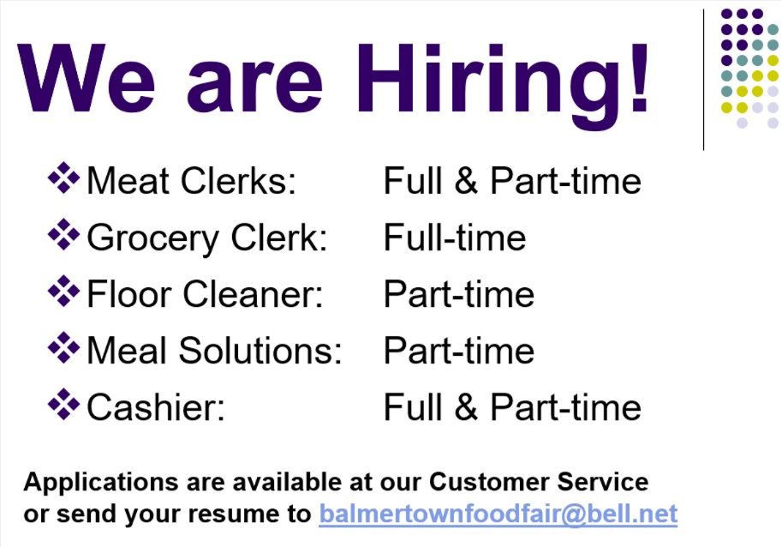***

**KEEWATIN PATRICIA DISTRICT SCHOOL BOARD:**

* Mental Health and Addictions Nurse
* Lunch Hour Supervisors
* Check out our website for open positions and more information on how to apply!

<http://www.kpdsb.on.ca/pages/view/employment-opportunities>

**LAFARGE CANADA INC.**

**Please visit the website for more information:** [**Job Listings at LafargeHolcim - HQ (icims.com)**](https://cacareers-lafarge-na.icims.com/jobs/search?ss=1&searchRelation=keyword_all&searchLocation=-12964-Red+Lake)

|  |  |
| --- | --- |
| **Plant Manager** | **Batcher - signing bonus when hired** |
| **Plant Operator - signing bonus when hired** | **Driver** |

**Please send your resume to Darren Wright:**[**darren.wright@lafargeholcim.com**](mailto:darren.wright@lafargeholcim.com)

**EXCELLENT ADVENTURES UPDATED \*\*\***

* + General Labourer
  + Moose Hunting Guide for Excellent Adventures
* **October 3 - October 10, 2022- Call Faron for more details**
* **Fly-in outposts and camps**

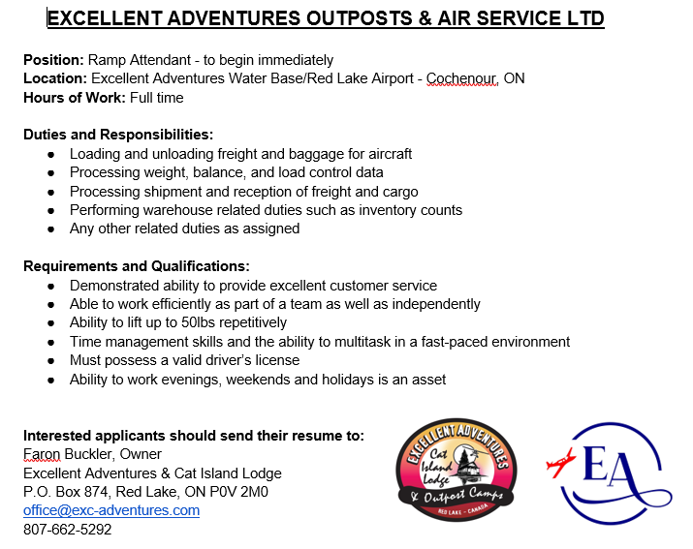

**PLEASE SEND RESUMES TO** [**office@exc-adventures.com**](mailto:office@exc-adventures.com) **or call (807) 662-5292/ 807-728-0277**

**NORTHWOOD LODGE:**

* **Part-time & Casual Dietary Aides**
* **Personal Support Workers**
* **Part-Time Maintenance**
* **Dietary Aides**

****

**NORTH STAR AIR:** 

Ground Support

|  |  |
| --- | --- |
| Hours of Work: | 05:00 am to 05:00 pm 4 days on 4 days off |
| Wages: | $24.54 to start, overtime is available |
| Duties & Qualifications:: | • Ensure excellent customer service, Accurately produces all freight loads for company aircraft according to the prescribed aircraft weight and balance prior to scheduled departure time, Maintain accurate records of all incoming and outgoing freight, Cargo acceptance and inventory control, Follow company policies and procedures when accepting dangerous goods, Perform and uphold North Star’s Customer Service Standards to both internal and external customers, Any other related duties as assigned |
| Requirements:: | High school diploma or equivalent is an asset, Previous shipping and receiving experience is an asset, Demonstrated ability to operate material handling equipment including forklift truck, Able to communicate both verbally and in writing, Basic mathematical skills, Able to work efficiently as a part of a team as well as independently, Ability to communicate in Oji-Cree or Ojibway is an asset, Ability to lift up to 40lbs; Repetitively, Ability to work inside and outside for long periods of time in the heat and cold |

**Submit your resume here** [**mmcguigan@northstarair.ca**](mailto:mmcguigan@northstarair.ca)

**BARRENS NORTHERN:**



1304928 Ontario Inc.

**Barrens Northern Transportation**

Box 1056, #81-Hwy 105

Red Lake, ON P0V 2M0

Ph (807) 727-3533 Fax (807) 727-3097

[barrens@bellnet.ca](mailto:barrens@bellnet.ca)

**SHOP LABOURER**

Barrens Northern Transportation is looking for a Shop Labourer. Duties would include: parts shipping and receiving, cleaning of equipment/trucks, maintenance of the shop. Shifts would be Monday to Friday – 8 Hrs per day. Competitive Wage, Benefits & RSP available. Please send resume to [barrens@bellnet.ca](mailto:barrens@bellnet.ca) or in person 81 Hwy 105 Red Lake

**HEAVY EQUIPMENT OPERATORS**

* We are looking for skilled Heavy Equipment Operators to join our team! We are also willing to train the right candidate for the position. Dozers, excavators, rock trucks, loaders, compactors, etc.
* Requirements: Ability to problem solve and prioritize. A strong commitment to all health & safety guidelines
* We Offer: Competitive wage, based on experience. Comprehensive benefits package + RSP's
* Applicants are required to submit their resume to [barrens@bellnet.ca](mailto:barrens@bellnet.ca) or in person.

**TRUCK DRIVERS**

* We are looking for skilled Truck Drivers to join our team! AZ drivers required for long/short hauls, low bedding, gravel haul. DZ drivers required for dump trucks & top kick.
* Requirements:
  + Valid AZ/DZ driver's license
  + Drivers Abstract. Pre-Trip Inspections/Daily Log Sheets
  + A strong commitment to all health & safety guidelines
* We Offer: Competitive wage, based on experience. Comprehensive benefits package + RSP's
* APPLY by email at: [barrens@bellnet.ca](mailto:barrens@bellnet.ca)

**PURE GOLD: UPDATED \*\*\***

Mine engineer Senior Mine Engineer

Environmental Monitor Production Geologist

Drilling Geologist Human Resources Generalist

Dry-Person Cleaner Metallurgical Technician

Millwright Mill Operator

Heavy Duty Mechanic Conventional Miner

Jumbo Operator Long Hole Driller

Mine Helper/Nipper Underground Mining Supervisor

Underground Miner Underground Trucker

Mine Clerk Instrumentation Process Control Technician

Please visit the website for more information and to apply: <https://www.puregoldmining.ca/careers/>

**TIKINAGAN CHILD & FAMILY SERVICES: **

**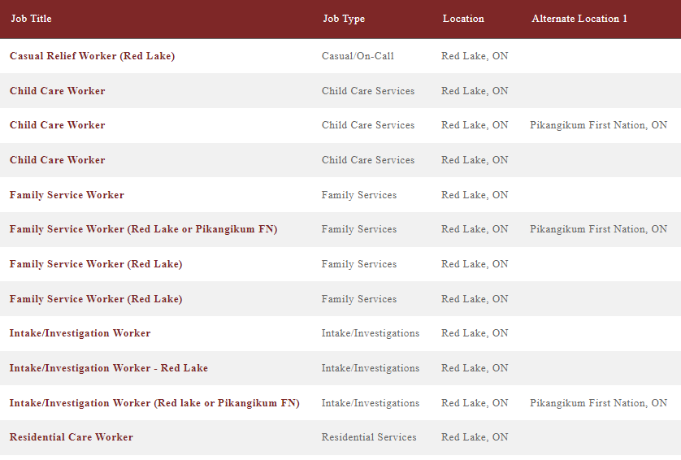**

TO APPLY:  BY MAIL: P.O. Box 627, Sioux Lookout, ON  P8T 1B1 OR BY FAX: (807) 737-4550 OR BY EMAIL: [**HR@tikinagan.org**](mailto:HR@tikinagan.org)  OR DROP OFF YOUR APPLICATION AT ANY OF OUR OFFICES (ask the receptionist to fax your application to Human Resources)

**THE STANDARD:**

****

**Customer Experience Representative**

We are currently looking for a highly motivated individual to join our team of dedicated insurance professionals at our Red Lake office in the position of Customer Experience Representative.

Here at The Standard, we place high value in being a part of the community and look for those who care for the community that they live and work. With 8 offices and growing we are looking for an individual who is interested in growing with us. If you are someone who is looking for a career to grow in, you could be a great fit for our team!

**About You**

* You are able to provide exceptional customer service to the community
* You can communicate effectively both in writing, over the phone and in person
* You can multitask, prioritize and manage your time to meet deadlines
* You like a fast-paced environment
* You can work in both a team and are motivated to work on your own
* You are proficient in Microsoft programs and can grasp new programs with ease
* You have your High school Diploma or equivalent

**About the job**

* Working at the front desk you will serve as the first impression for our clients in Red Lake
* Actively communicate with co-workers, clients and our 7 other branches
* Communicate the needs of clients with the Insurance Advisors
* Prepare, and distribute mail and courier packages
* Help with special projects as they arise

**About the Benefits**

* A full-time position starting as soon as possible.
* A competitive compensation package, including a comprehensive group benefits plan and a company matching RSP plan
* Birthday or work anniversary off
* Personal time and Vacation time after successful completion of probationary period
* Annual Health and Wellness Reimbursement
* Company paid continuing education
* Continuous opportunity to grow within the company
* Modern technology and work environment

If this sounds like a career you are interested in, we would love to hear from you! Please send your resume and cover letter to:

**The Standard Insurance Attn: Mackenzie Patterson**  
319 Second Street South Kenora, ON P9N 3X8  
(P) 1.807.468.3333 (F) 1.807.468.4289  
[careers@standardinsurance.ca](mailto:careers@standardinsurance.ca)

Salary based upon experience. Only those chosen for an interview will be contacted.

*The Standard welcomes and encourages applications from people with disabilities. Accommodations are available on request for candidates taking part in all aspect of the selection process.*

**FOUNTAIN TIRE:**

Fountain Tire Red Lakeis searching for a friendly and dedicated individual to perform **Insides Sales and Service Writing duties**.

As part of the front-line staff, the Inside Sales Representative is responsible for ensuring that all customers are provided with top-notch customer service, consultation and explanation of required tire service and tire requirements. Your duties will include:

* Greeting and communicating with customers on all aspects of service
* Sharing product knowledge and technical expertise with Fountain Tire customers to build existing and new business.
* Providing service quotes and receiving customer authorization for work to be performed on customer vehicles, finalizing sales, and completing customer follow up.
* Scheduling customer appointments for tire services.
* Recommending tire service, specialty tire service, and wheel service to customers.
* Ensuring that all products are billed accurately to the customer.
* Completing proactive calls to customers to determine their satisfaction level with the service received.

What does it take to get on track?

* Previous experience in the tire industry an asset
* Excellent customer service and time management skills
* 1 to 2 years of retail Customer Relations and or Customer Service.
* Strong interpersonal skills with ability to build a team and work as a team.
* Ability to work well under pressure in a fast paced, ever changing high-volume environment
* Current, valid driver’s license

What do we offer? At Fountain Tire, you’ll have a great place to work:

* Competitive compensation- Starting at $18/hour based on experience
* The opportunity to work with an excellent team and great customers
* Regular day shifts
* Great discounts for you and your family on tires, parts, and mechanical services
* Health, Dental and Vision Benefits and RRSP Matching Program
* The opportunity to enter our management training program to become a store Manager/Partner

**Fountain Tire** **Red Lake** is looking for responsible, safe and dedicated associates to join our team as an Automotive **Tire Technicians**!

 What each day will bring:

* Something different! You never know what kind of vehicle or tire you may be required to work on
* You could be inspecting, installing, balancing, rotating, and/or repairing passenger or light truck tires/wheels
* Amazing customers to impress with your professional and friendly customer service
* The responsibility to keep yourself and your coworkers’ safe
* Pride in the work you've done keeping your customers safe and on the road!

What kind of person are we looking for?

* We would love to find an expert in the passenger tire field but will also consider applicants with a mechanical background and the desire to learn
* A valid driver's license is a must. We also need to see that you are responsible on the road by providing a satisfactory driver's abstract
* This work can unpredictable, physical, wet etc. and we need someone who will be up for the challenge
* Someone who is ready to work hard, Monday through Saturday

What is in it for you?

* We will develop your skills and certifications with our excellent training
* We take care of you and your family with our impressive health, dental and vision benefits
* A retirement savings plans with company matching to help you achieve your financial goals
* Save your money with our staff discounts on tires, parts and mechanical services at all Fountain Tire locations

**Apply online today! at fountaintire.com/careers/**

**EVOLUTION MINING:**

**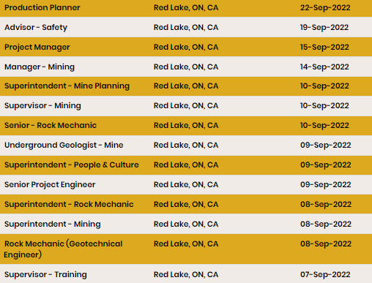**

**Apply to/Full Job Descriptions:** [Careers at Evolution Mining Limited](https://careers.evolutionmining.com.au/search/?q=&q2=&alertId=&locationsearch=&title=&location=red+lake&date=)

**RED LAKE INDIAN FRIENDSHIP CENTRE:**  **Financial Administrator:**

The Financial Administrator will be required to provide oversight and supervision to staff reporting directly. Responsibilities will include monitoring of accounts payables and receivables. Ensure invoices are issued promptly. Prepare monthly, quarterly & annual reports for submission to the Board of Directors and funding agencies as required. These will include, but not be limited to annual cash flows, monthly bank reconciliations, monthly and quarterly income statements and financial reports.

Assist in the preparation of program budgets and grant writing proposals.

Provide recommendations for improvements including processes, systems and policy that safeguard the assets of the non-profit charity. Willingness to participate in training as required.

**Homelessness Outreach Worker:**

The Homelessness Outreach program provides a range of services and supports for Indigenous individuals to aid in preventing homelessness while ensuring that individuals have access to the necessary tools to assist themselves. The program will promote access to life skills, job readiness, health and cultural supports. This program provides a continuum of supports while coordinating a community driven approach to addressing homelessness in Red Lake. The Homelessness Outreach Worker will advocate for individuals and families with employment assistance workers, landlords, hotel managers and others, as required support during housing search process. Will also offer assistance with connecting to community resources, such as income and rental assistance.

**Supportive Housing Coordinator: (Kaabeshiwiin - Part Time- 1 Year Contract ending March 31, 2023)**

Responsible for completing intake and review process with prospective clients; Provide light support to tenants involved in the program, including, but not limited to home maintenance, budgeting, cooking and other basic life skills; Responsible for preparing program reports, monthly quarterly, annually as per contract; Ability to complete monthly subsidies and arrears payments in a timely manner, ensuring all applications are complete; Excellent computer skills

**Akwe:go:**

**The Akwe:go program is grounded in cultural traditions providing a sense of belonging for urban Indigenous children ages 7 – 12.**The program offers a variety of strategies such as one-to-one activities, group activities, and family circles to encourage positive behaviours and wellbeing. The program supports individualized goals to enhance the child’s area of need; supporting social skills, educational intervention, individuals with disabilities, violence prevention, children in care or at risk of being in the care of the Children’s Aid Society, 2SLGBTQ+ supports, and positive nutrition and physical activity practices. The Akwe:go program provides a space where urban Indigenous children can feel safe to be themselves and accepted.

**Driver: (Part-time)**

Must be flexible to meet the needs of program staff. Able to run errands, ability to lift up to 50 lbs. max. Clean Driving record with proof of previous fleet insurance coverage is essential. Ability to work independently as well as in a group setting.

**FAS/D Community Support Worker:**

To assist in the preparation, articulation and implementation of a nutrition and FAS/FAE strategies and resources for the Centre. Facilitate educational presentations, workshops and community outreach for individuals and agencies affected by FAS/FAE. Implement schedule of programs and services for those affected by FAS/FAE. Provide advocacy and referrals for clients registered with the program.

**Urban Aboriginal Healthy Living Program Coordinator: (Maternity Leave 1 Year Contract ending July 16, 2023)**

The coordinator is responsible to design, develop, coordinate, facilitate, monitor and evaluate healthy lifestyle programs based on community needs and interests. The coordinator will ensure that program design and delivery, complies with all Friendship Centre and OFIFC standards of performance and that all program requirements are attained. Plan, organize, supervise, assess and facilitate physical fitness and recreation programs; sport activities, healthy eating and weight management programs, youth leadership and smoking cessation programs appropriate for participant knowledge base and physical capabilities.

**Qualifications - All Positions:**

* Post-secondary degree/diploma in Social/Human Services, Indigenous Studies or equivalent training combined with relevant work experience
* Valid Ontario Driver’s License & access to a vehicle
* Ability to speak, read & write an indigenous language an asset
* Must be able to provide a satisfactory Vulnerable Sector Check
* Provide or able to obtain First Aid/CPR, WHMIS & Safe Food Handling Certification
* Participate in training as required.

Interested Candidates should submit their resume & 3 references to:

**Peter Campbell**

Executive Director

Red Lake Indian Friendship Centre

P. O. Box 244

Red Lake, ON P0V 2M0

[director@rlifc.ca](mailto:director@rlifc.ca)

**EAR FALLS**

**COPPERHEAD CONTRACTING INC. 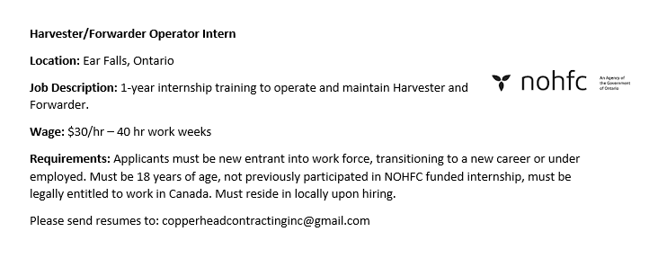**

**EMCON SERVICES:**

**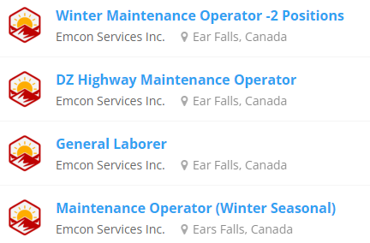**

**Please visit** [**EMCON**](https://www.emconservices.ca/jobs-ontario.html) **for more information and to apply.**

cid:image001.png@01D85977.47FCA6B0 **Recruiting for Interfor, Ear Falls…**

* Production Technician
* Maintenance Planner in Training
* Woodland Operations Supervisor
* Buyer
* Human Resources Manager
* Millwright
* Heavy Duty Equipment Mechanic

**For more information visit:** [For more HLC Talent click here](https://linktr.ee/hlctalent)

**KENORA DISTRICT SERVICES BOARD**

[***Casual Registered ECEs/ECE Assistants – Ear Falls***](https://kdsb.on.ca/jobs/casual-registered-eces-ece-assistants-ear-falls-4/)

**For more information, to see full job descriptions on each position and to apply please visit:** [**https://kdsb.on.ca/join-our-team/**](https://kdsb.on.ca/join-our-team/) **or click on the position below…**

**-END-**