# RLCES_Logo2EO-LogoTag-Eng_BW_revEO-LogoTag-Fr_BW_rev

# P.O. Box 223 / 146 Howey Street Red Lake, ON P0V 2M0

[**www.redlakejobs.ca**](http://www.redlakejobs@shaw.ca) **/** [**redlakejobs@shaw.ca**](mailto:redlakejobs@shaw.ca)

Tel: (807) 727-2297 / Fax: (807) 727-1176

# Job Postings for the Red Lake/Ear Falls area

**August 3rd, 2022**

**RED LAKE**

**RED LAKE CAREER & EMPLOYMENT SERVICES: NEW\*\*\***

* **Employment Adviser**
* Full-time; permanent; wage dependent on background and experience; group benefits; pension; great working environment!

Responsibilities:

* Provide client service to job seekers, in the form of clarifying employment needs, and job search assistance.
* Administrative duties pertaining to documentation, file maintenance, and statistical reporting: proficient with Microsoft Office applications, database and Internet.
* Marketing of programs to area employers, potential job seekers, and community at large.
* Workshop presentations to various client groups.

Knowledge, Skills & Abilities:

* Office administrative procedures and ability to maintain a high level of accuracy, with attention to detail.
* Adhere to strict candidate and employer confidentiality.
* Demonstrated excellent interpersonal skills.
* Demonstrated team building skills.
* Demonstrated effective analytical and problem solving.
* Effective verbal, written and listening communication skills.
* Time management skills.
* Must be honest, and trustworthy.
* Possess cultural awareness and capability.
* Demonstrate sound work ethics.

Qualifications:

* Related post-secondary education (i.e. Employment Counselling, Career Development, Social Work).
* Demonstrated knowledge and understanding of employment and training sector.
* Demonstrated knowledge and understanding of challenges faced by Northern Ontario job seekers.
* Clear Criminal Background Check and Vulnerable Sector Screening required.
* Must have valid driver’s license and access to a vehicle.

**Submit resume and cover letter by 12:00 Noon, Friday, August 19th, 2022 to:**

Sandra Marshall, Director

Red Lake Career & Employment Services

P.O. Box 223 / 146 Howey Street

Red Lake, ON P0V 2M0

e-mail: [redlakejobs@shaw.ca](mailto:redlakejobs@shaw.ca) / Fax: (807) 727-1176 / Tel: (807) 727-2297

*We will make available accommodations for job applicants who have disabilities. Accommodations for people with disabilities are available on request for interviews and selection processes.*

*This Employment Ontario program is funded in part by the Government of Canada and the Government of Ontario, and sponsored locally by Red Lake Margaret Cochenour Memorial Hospital.*

**NEW STARTS WOMEN SHELTER: NEW\*\*\***

**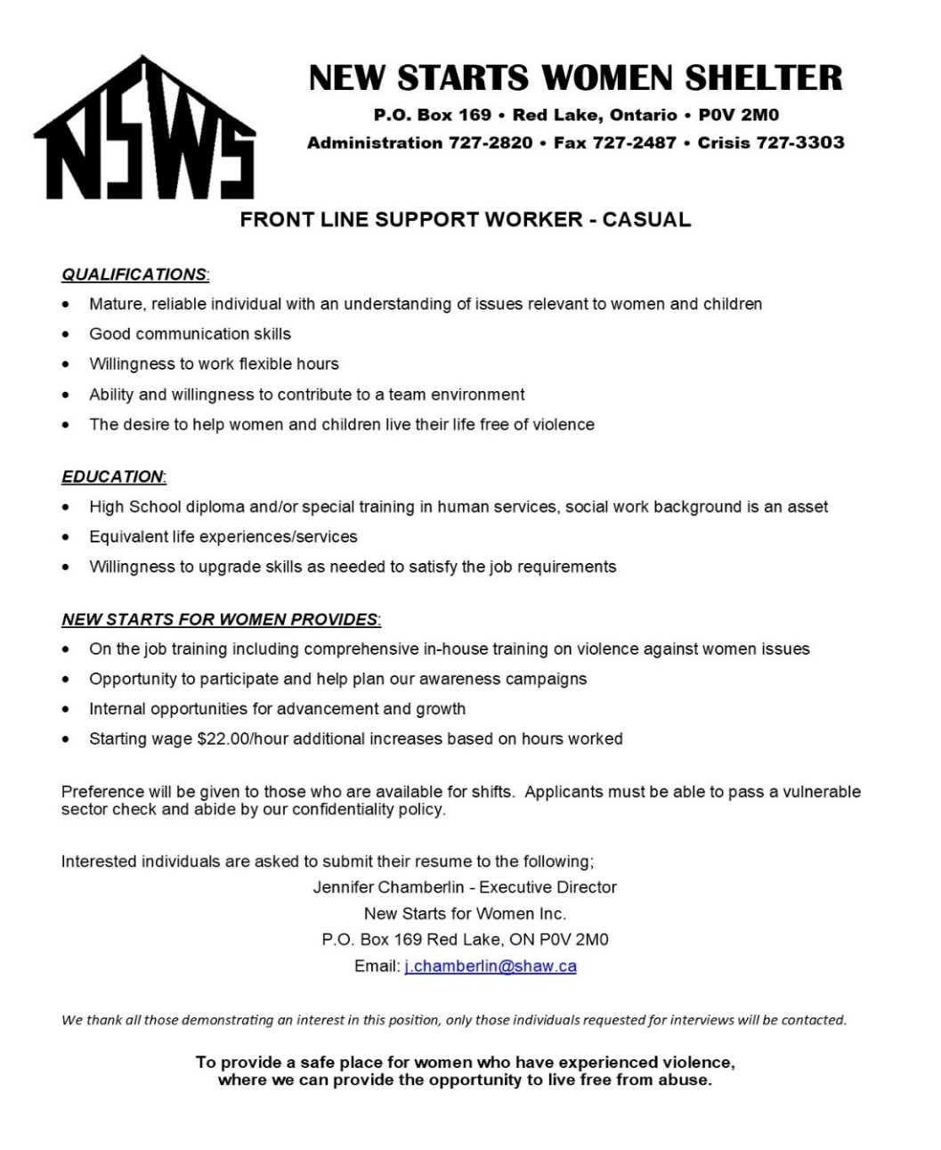**

**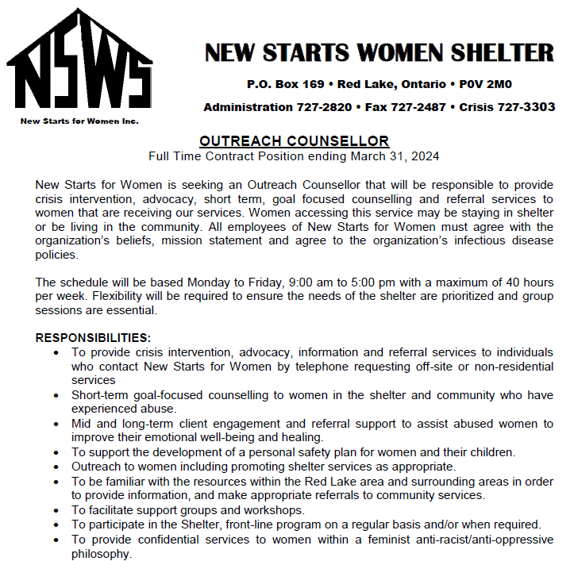**

**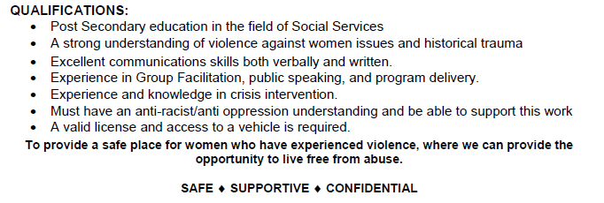**

****

**BALMER HOTEL: NEW\*\*\***

**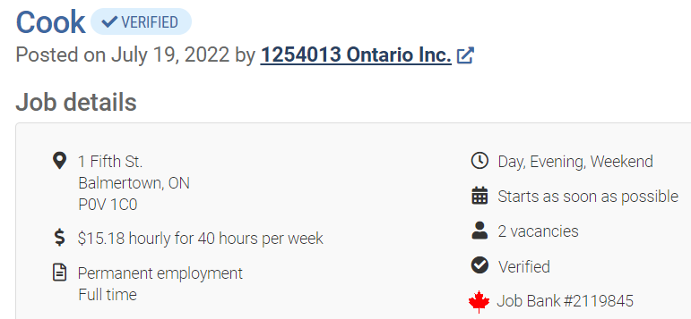**

**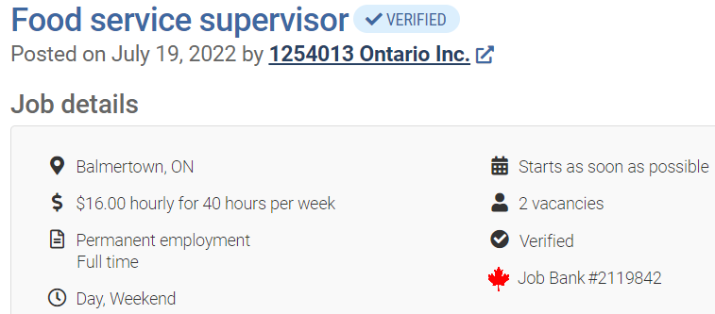**

**To apply please email your resume to:** [balmerhotel@hotmail.com](mailto:balmerhotel@hotmail.com)

***NEW \*\*\*HARMONY CENTRE FOR COMMUNITY LIVING***

*“Working Together Today for an Independent Tomorrow”*

*26 Young Street, P.O. Box 906, RED LAKE, Ontario POV 2MO*

*Phone: (807) 727-2828 Fax: (807) 727-1102*

*If you are looking for a rewarding career opportunity, look at us: Harmony Centre for Community Living and the Red Lake and District Association for Community Living has been providing support services to individuals living with developmental disabilities for over 60 years in our community. We want you to join our team!*

**Full Time Support Staff**

**Day Program, Independent Living Department (ILD) and Respite**

**Positions Available**

As a full time employee, you will provide opportunities for the person (s) supported to experience growth, quality of life, inclusion and equality within our community to their fullest potential, focusing on deepening his/her relationships, achieving a sense of health and well-being, providing opportunities to have fun in ordinary community places, helping to recognize their own personal power while learning valuable skills, and by identifying positive and socially acceptable methods to meeting a person’s needs.

**Required Education, Skills and Qualifications**

* Threshold Competencies (Flexibility, Self-Control. Service Orientation, Values and Ethics)
* Excellent Communication Skills – both oral and written
* Competent Computer Skills and Internet Experience
* Experienced driver with a valid Driver’s Licence and the maintenance of an acceptable driving record
* Experience in a team environment is essential, but also the ability to work alone is essential
* A secondary school diploma or equivalent
* A diploma in the field of Developmental or Social Services is preferred; however, we offer on-the-job training for those entering the field for the first time.
* Applicants will be ready to work flexible hours.

Job Type: Full-time, Day shifts Monday to Friday, Great Benefit Package after three months

Salary: $23.33 – $25.36 per hour

Apply to: Harmony Centre for Community Living Hiring Committee

Email: [Shirley.Jette@shaw.ca](mailto:Shirley.Jette@shaw.ca) or [Jennifer.Parsons@shaw.ca](mailto:Jennifer.Parsons@shaw.ca) /

Deadline for Applications: noon on Monday, August 15, 2022

BOART LONGYEAR:

|  |  |
| --- | --- |
| Job Title: | Site Clerk |
| Employer/Contact Name: | Janela MacBurnie |
| Location/Address: | Red Lake |
| Application Deadline: | 8/5/2022 |
| Email: | [ela.macburnie@boartlongyear.com](mailto:ela.macburnie@boartlongyear.com) |
| Phone Number: | (437) 266-8606 |
| Hours of Work: |  |
| Wages: |  |
| Duties & Qualifications:: | Boart Longyear is looking to hire a site clerk in Red Lake, ON.  Boart Longyear is a leading global supplier of drilling services, drilling equipment and performance tooling. It also has a substantial presence in aftermarket parts and service, energy, mine dewatering, oil sands exploration, and production drilling.  The Global Drilling Services division operates in 30 countries for a diverse mining customer base spanning a wide range of commodities, including copper, gold, nickel, zinc, uranium, and other metals and minerals. The Global Products division designs, manufactures and sells drilling equipment, performance tooling, and aftermarket parts and services to customers in over 100 countries.  Position Responsibilities: Provide administrative support to the site supervisor and entire drilling services team Responsible for sending in correspondence to our clients and head office Receive, review and organize dailies, documents and reports. Accurately enter daily operation logs/timesheet data and submit for the contracts to be administered Submit payroll hours the regional head office Demonstrate ability to work confidential information Analyze daily field reports Accurate and efficient data entry skills Prepare courier packages as required Act proactively to keep all project site documentation up to date Communicate effectively with the regional head office Assist the site supervisor with new hires, including onboarding, training and orientation Assist the Site Supervisor and team with other tasks as required |
| Requirements:: | College Diploma in business administration is considered an asset 2-3 years of administrative experience Demonstrate strong skills in MS office, Excel, Word, PowerPoint, and Outlook Solid written and verbal communication skills Organization and time management skills Effective and professional communication with all clients and company representatives Ability to work overtime (as required) Strong sense of direction with minimal supervision Ability to meet pressing deadlines Commitment to ethical business conduct |
| How to Apply:: | If interested, please email resume to [ela.macburnie@boartlongyear.com](mailto:ela.macburnie@boartlongyear.com) with Subject title "Site Clerk - Red Lake" |
| Job Type:: | Full Time |

**BOART LONGYEAR: NEW\*\*\***

**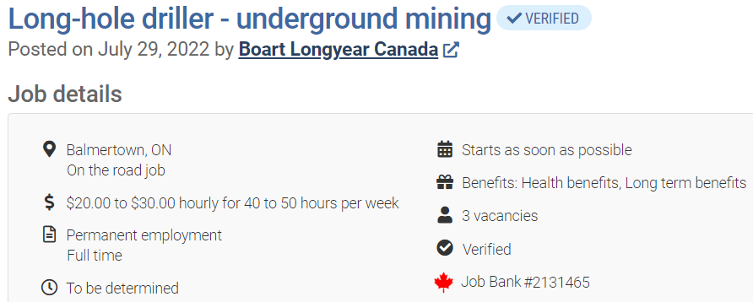**

**Pease apply via email at** [ela.macburnie@boartlongyear.com](mailto:ela.macburnie@boartlongyear.com)

HOME HARDWARE: NEW\*\*\*

## Job Details

Full-time

238 Howey Street, Red Lake, Ontario P0V2M0

Posted about an hour ago

## Job Description

Shipping Duties: Prepare all documents required for each shipment. (Including Bill of Lading, customs and duties paperwork.) Arrange transportation. Ensure shipments are cleared for shipping by Accounting before calling for pick-up. Return shipping papers to Accounting. Post / Notify Material Handler that truck will be coming for pick-up. Receiving Duties: Enter receiving information in Cashier Pro. Call supplier if parts are missing or backordered and update Cashier Pro purchase order revised delivery column. Buying Duties: Purchase and maintain stock hardware supplies. Prepare and maintain semi annual Inventory Count. Ensure invoice matches with purchase order and stamp category on each invoice. Check all Purchase Orders prior to scheduled delivery date to ensure they will arrive as scheduled. Qualifications: Must have the skills to maintain clear communications among the office, subcontractors, supplies, and the Shop. Must posses excellent verbal and written communications skills. Must have basic familiarity with accounting procedures. Required experience in shipping receiving and inventory control. Computer literacy. We thank all those who apply however, only applicants chosen for an interview will be contacted. Please include email address and direct contact information on your resume.

**Red Lake Taxi: Driver**

Full-time and part-time positions available

You must have:

clean drivers record

25+ yr old

full G licence

You must be able to obtain: vulnerable sector check, drivers abstract, taxi driver licence.

Please send resumes to: [mallorey.parsons@hotmail.com](mailto:mallorey.parsons@hotmail.com)

**TIM HORTONS:**

**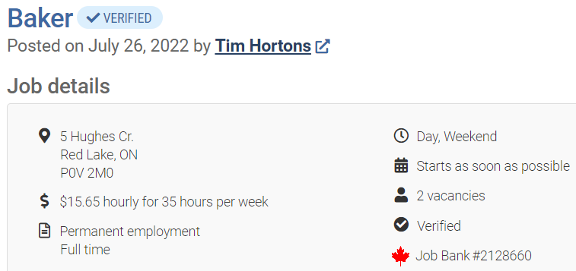**

**Apply by email:** [**info@ajccanada.com**](mailto:info@ajccanada.com)

**Advertised until 2022-08-09**

**KENORA DISTRICT SERVICES BOARD:**

[***Temporary, Full-Time Integrated Services Worker – Open to the District***](https://kdsb.on.ca/jobs/temporary-full-time-integrated-services-worker-open-to-the-district/)

[***Two (2) Temporary, Part-Time Registered ECE’s or ECE Assistants – Red Lake***](https://kdsb.on.ca/jobs/11724/)

[***One (1) Regular, Full-Time Early Years Quality Assurance Coordinator – Red Lake***](https://kdsb.on.ca/jobs/one-1-regular-full-time-early-years-quality-assurance-coordinator-red-lake-2/)

[***Temporary, Part-Time Shelter Attendant – Red Lake***](https://kdsb.on.ca/jobs/temporary-part-time-shelter-attendant-red-lake-2/)

[***Temporary, Part-Time Weekend Day Shift Shelter Attendant – Red Lake***](https://kdsb.on.ca/jobs/temporary-part-time-weekend-day-shift-shelter-attendant-red-lake/)

[***One (1) Temporary, Full-Time EarlyON Child and Family Centre Coordinator – Red Lake***](https://kdsb.on.ca/jobs/one-1-temporary-full-time-earlyon-child-and-family-centre-coordinator-red-lake/)

[***Temporary Part-Time Shelter Attendant – Red Lake***](https://kdsb.on.ca/jobs/temporary-part-time-shelter-attendant-red-lake/)

[***Temporary Full-Time Shelter Attendant – Red Lake***](https://kdsb.on.ca/jobs/temporary-full-time-shelter-attendant-red-lake/)

[***Permanent, Full-Time, Registered ECEs or ECE Assistants – Red Lake***](https://kdsb.on.ca/jobs/permanent-full-time-registered-eces-or-ece-assistants-red-lake/)

[***Casual Registered ECEs/ECE Assistants – Red Lake***](https://kdsb.on.ca/jobs/casual-registered-eces-ece-assistants-red-lake/)

[***Casual Registered ECEs/ECE Assistants – Ear Falls***](https://kdsb.on.ca/jobs/casual-registered-eces-ece-assistants-ear-falls-4/)

**\*\*\*Please click the link below or click a specific job post to see full job descriptions for positions at KDSB:** [**https://kdsb.on.ca/join-our-team/**](https://kdsb.on.ca/join-our-team/)

**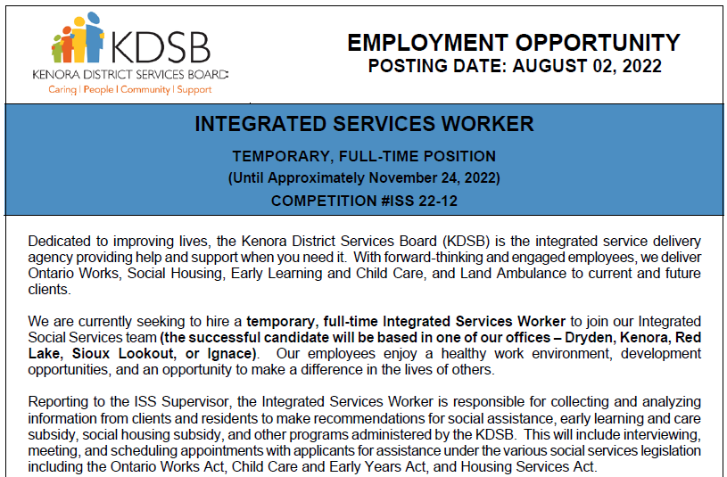**

**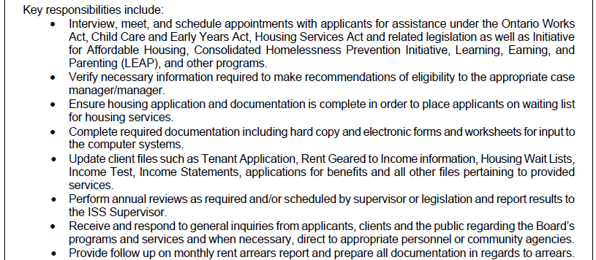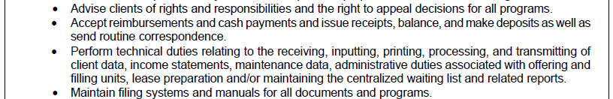**

**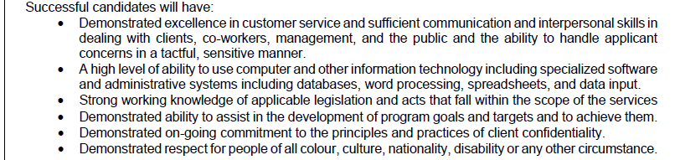**

**KENORA CATHOLIC DISTRICT SCHOOL BOARD**

Mental Health Worker

Custodian

Casual Custodian

Student Well Being Coach

Occasional Teacher’s (Qualified and Unqualified)

**To see full job descriptions and how to apply visit the website:**

[Employment - Kenora Catholic District School Board (kcdsb.on.ca)](https://www.kcdsb.on.ca/our_board/leadership/services/human_resource_services/employment)

**WESTLAND INSURANCE:**

****

****

**For more information and click to:** [**Apply Here**](https://can62e2.dayforcehcm.com/CandidatePortal/en-US/westlandcorp/Posting/View/4978)

**NORTHWOOD LODGE:**

**Part-time & Casual Dietary Aides**

**Part-time Maintenance**

**Personal Support Workers**

****

****

**NATURES INN:**

Nature's Inn Red Lake is looking for a Housekeeper to start immediately.

This is a full-time position with an average of 25-35 hours per week. Must be available during the week and weekends.

Starting wage $18.00/hr, successfully finish a 3-month probationary period, and wage increases to $19/hr.

Please send your cover letter and resume to [thayward@naturesinn.ca](mailto:thayward@naturesinn.ca). For more information, please call Tess Hayward at 807-735-2636

**RED LAKE GOLF AND COUNTRY CLUB:**

****

**WALSH CONTRACTING LTD. -** Carpenter

General Requirements:

1. Must have physical abilities to perform general construction work.

2. Special Construction work experience (Painting, roofing, drywall, framing,brushing, siding, misc.carpentry).

3. Ensure tasks are completed according to standards and expectations set forth by the scope of the contract.

4. Must have a vehicle and valid driver’s license.

Wage rate: Depending on the experience.

                   Minimum of $20.00 / hr. Seasonal job

**If interested kindly send your résumé to:** [**bewalsh@hotmail.ca**](mailto:bewalsh@hotmail.ca)

**BALMERTOWN FOOD FAIR:**

Meat Clerk:   
32 - 40 hours/week  
Involves wrapping, pricing, stocking, cleaning, serving customers, assisting meat cutter. Must be able to lift 50lb. All training is provided.

Grocery Clerk:  
14 - 22 hours/week  
Involves cleaning, stocking, assisting customers and supervisors. All training is provided.

To apply send your resume to balmertownfoodfair@bell.net or pick up an application at our customer service.

**BARRENS NORTHERN:**



1304928 Ontario Inc.

**Barrens Northern Transportation**

Box 1056, #81-Hwy 105

Red Lake, ON P0V 2M0

Ph (807) 727-3533 Fax (807) 727-3097

[barrens@bellnet.ca](mailto:barrens@bellnet.ca)

**SHOP LABOURER**

Barrens Northern Transportation is looking for a Shop Labourer. Duties would include: parts shipping and receiving, cleaning of equipment/trucks, maintenance of the shop. Shifts would be Monday to Friday – 8 Hrs per day. Competitive Wage, Benefits & RSP available. Please send resume to [barrens@bellnet.ca](mailto:barrens@bellnet.ca) or in person 81 Hwy 105 Red Lake

**HEAVY EQUIPMENT OPERATORS**

* We are looking for skilled Heavy Equipment Operators to join our team! We are also willing to train the right candidate for the position. Dozers, excavators, rock trucks, loaders, compactors, etc.
* Requirements: Ability to problem solve and prioritize. A strong commitment to all health & safety guidelines
* We Offer: Competitive wage, based on experience. Comprehensive benefits package + RSP's
* Applicants are required to submit their resume to [barrens@bellnet.ca](mailto:barrens@bellnet.ca) or in person.

**TRUCK DRIVERS**

* We are looking for skilled Truck Drivers to join our team! AZ drivers required for long/short hauls, low bedding, gravel haul. DZ drivers required for dump trucks & top kick.



* Requirements:
  + Valid AZ/DZ driver's license
  + Drivers Abstract. Pre-Trip Inspections/Daily Log Sheets
  + A strong commitment to all health & safety guidelines
* We Offer: Competitive wage, based on experience. Comprehensive benefits package + RSP's
* APPLY by email at: [barrens@bellnet.ca](mailto:barrens@bellnet.ca)

**SUMMER STUDENT:**

* We are looking for a student to assist in our shop.  Student would assist with shop maintenance, fleet maintenance, labour etc.  A good opportunity if someone is interested into going into the heavy equipment mechanic field.

**IGA:**

* **Full- time meat cutter & Part-time meat cutter**
* **Part-time cashier (3)**
* **Part-time deli clerk & Part-time courtesy clerk**
  + ***Contact Red Lake Career & Employment Services for full Job Descriptions!***

**THE STANDARD: UPDATED\*\*\***

****

**Customer Experience Representative**

We are currently looking for a highly motivated individual to join our team of dedicated insurance professionals at our Red Lake office in the position of Customer Experience Representative.

Here at The Standard, we place high value in being a part of the community and look for those who care for the community that they live and work. With 8 offices and growing we are looking for an individual who is interested in growing with us. If you are someone who is looking for a career to grow in, you could be a great fit for our team!

**About You**

* You are able to provide exceptional customer service to the community
* You can communicate effectively both in writing, over the phone and in person
* You can multitask, prioritize and manage your time to meet deadlines
* You like a fast-paced environment
* You can work in both a team and are motivated to work on your own
* You are proficient in Microsoft programs and can grasp new programs with ease
* You have your High school Diploma or equivalent

**About the job**

* Working at the front desk you will serve as the first impression for our clients in Red Lake
* Actively communicate with co-workers, clients and our 7 other branches
* Communicate the needs of clients with the Insurance Advisors
* Prepare, and distribute mail and courier packages
* Help with special projects as they arise

**About the Benefits**

* A full-time position starting as soon as possible.
* A competitive compensation package, including a comprehensive group benefits plan and a company matching RSP plan
* Birthday or work anniversary off
* Personal time and Vacation time after successful completion of probationary period
* Annual Health and Wellness Reimbursement
* Company paid continuing education
* Continuous opportunity to grow within the company
* Modern technology and work environment

If this sounds like a career you are interested in, we would love to hear from you! Please send your resume and cover letter to:

**The Standard Insurance Attn: Mackenzie Patterson**  
319 Second Street South Kenora, ON P9N 3X8  
(P) 1.807.468.3333 (F) 1.807.468.4289  
[careers@standardinsurance.ca](mailto:careers@standardinsurance.ca)

Salary based upon experience. Only those chosen for an interview will be contacted.

*The Standard welcomes and encourages applications from people with disabilities. Accommodations are available on request for candidates taking part in all aspect of the selection process.*

**THE BEER STORE**

Customer Service Representative  
Looking for part-time CSR

Fun & fast-paced work environment with opportunities to grow within the company. Must be 18 years of age or older

**Apply online at**[**http://www.thebeerstore.ca/about-us/careers/retail**](https://can01.safelinks.protection.outlook.com/?url=http%3A%2F%2Fwww.thebeerstore.ca%2Fabout-us%2Fcareers%2Fretail&data=04%7C01%7Cstore3494%40thebeerstore.ca%7C2b3e690662ae46787b1308da05d8b4ef%7C7f426c913c5c44be8717ea93f235e35b%7C1%7C0%7C637828725554438005%7CUnknown%7CTWFpbGZsb3d8eyJWIjoiMC4wLjAwMDAiLCJQIjoiV2luMzIiLCJBTiI6Ik1haWwiLCJXVCI6Mn0%3D%7C3000&sdata=rQihd4J4TV5vjDGs0UlZ1iIr3%2BRxh%2B303BakXYlGEqE%3D&reserved=0)

**NORTH STAR AIR:** 

Ground Support

|  |  |
| --- | --- |
| Hours of Work: | 05:00 am to 05:00 pm 4 days on 4 days off |
| Wages: | $24.54 to start, overtime is available |
| Duties & Qualifications:: | • Ensure excellent customer service, Accurately produces all freight loads for company aircraft according to the prescribed aircraft weight and balance prior to scheduled departure time, Maintain accurate records of all incoming and outgoing freight, Cargo acceptance and inventory control, Follow company policies and procedures when accepting dangerous goods, Perform and uphold North Star’s Customer Service Standards to both internal and external customers, Any other related duties as assigned |
| Requirements:: | High school diploma or equivalent is an asset, Previous shipping and receiving experience is an asset, Demonstrated ability to operate material handling equipment including forklift truck, Able to communicate both verbally and in writing, Basic mathematical skills, Able to work efficiently as a part of a team as well as independently, Ability to communicate in Oji-Cree or Ojibway is an asset, Ability to lift up to 40lbs; Repetitively, Ability to work inside and outside for long periods of time in the heat and cold |

**Submit your resume here** [**mmcguigan@northstarair.ca**](mailto:mmcguigan@northstarair.ca)

**PURE GOLD: UPDATED**

Please visit the website for more information and to apply: <https://www.puregoldmining.ca/careers/>

|  |  |
| --- | --- |
| [**Mine Engineer**](https://puregoldmining.bamboohr.com/jobs/view.php?id=35) | [**Metallurgical Technician - PGM20-0060**](https://puregoldmining.bamboohr.com/jobs/view.php?id=27) |
| [**Senior Mine Engineer**](https://puregoldmining.bamboohr.com/jobs/view.php?id=138) | [**Millwright**](https://puregoldmining.bamboohr.com/jobs/view.php?id=144) |
| [**Underground Surveyor**](https://puregoldmining.bamboohr.com/jobs/view.php?id=134) | [**Mill Operator**](https://puregoldmining.bamboohr.com/jobs/view.php?id=136) |
| [**Senior Accountant**](https://puregoldmining.bamboohr.com/jobs/view.php?id=143) | [**Heavy Duty Mechanic**](https://puregoldmining.bamboohr.com/jobs/view.php?id=23) |
| [**Production Geologist**](https://puregoldmining.bamboohr.com/jobs/view.php?id=26) | [**Conventional Miner**](https://puregoldmining.bamboohr.com/jobs/view.php?id=139) |
| [**Drilling Geologist**](https://puregoldmining.bamboohr.com/jobs/view.php?id=135) | [**Mine Helper/Nipper**](https://puregoldmining.bamboohr.com/jobs/view.php?id=146) |
| [**Recruiter**](https://puregoldmining.bamboohr.com/jobs/view.php?id=107) | [**Underground Mining Supervisor**](https://puregoldmining.bamboohr.com/jobs/view.php?id=112) |
| [**Dry Person- Cleaner**](https://puregoldmining.bamboohr.com/jobs/view.php?id=147) | [**Underground Mucker**](https://puregoldmining.bamboohr.com/jobs/view.php?id=141) |
| [**Underground Trucker**](https://puregoldmining.bamboohr.com/jobs/view.php?id=142) | [**Instrumentation Process Control Technician**](https://puregoldmining.bamboohr.com/jobs/view.php?id=145) |

**EXCELLENT ADVENTURES**

General Labourer

Ramp Attendant

**PLEASE SEND RESUMES TO** [**office@exc-adventures.com**](mailto:office@exc-adventures.com) **or call (807) 662-5292**

**Electrician Journeyman: UPDATED**

[KEN ANDERSON ELECTRIC INC](https://www.ziprecruiter.com/c/KEN-ANDERSON-ELECTRIC-INC/Jobs) [Red Lake, ON, Canada](http://maps.google.com/?q=Red%20Lake%2C%20ON%2C%20Canada&z=9)

**Compensation: $35 to $45 Hourly**

**Benefits Offered: Dental, Medical**

**Employment Type: Full-Time**

**Why Work Here?** *“Long time company with steady work.”*

We are currently seeking an Electrician Journeyman! You will strive to provide safe electrical systems for a variety of customers.

**Responsibilities:**

* Install and repair electrical equipment and fixtures
* Install various types of raceway and cable tray systems
* Troubleshoot motor and control systems
* Perform routine maintenance on electrical wiring and systems
* Adhere to all quality and safety codes

​​**Qualifications:**

* Previous experience in electrical engineering or other related fields
* Familiarity with electrical schematics, blueprints, and manuals
* Familiarity with electrical equipment and hand tools
* Strong problem solving and critical thinking skills

Company address: 16 YOUNG STREET PO BOX 917

Posted until 08/05/2022

**Interested individuals can apply by email at** [**kaeaccounts@shaw.ca**](mailto:kaeaccounts@shaw.ca)

**KINROSS: Great Bear Resources: Updated\* **

|  |  |
| --- | --- |
| [**Safety & Training Superintendent**](https://jobs.kinross.com/job/Red-Lake-Safety-&-Training-Superintenden-Onta/868477100/) | Red Lake, Ontario, Canada |

Apply to: [Careers at Great Bear Resources A Kinross Company](https://www.kinross.com/careers/)

**EMCON SERVICES:**

* + General Laborer Seasonal
  + Winter Seasonal Maintenance Operator (3 openings)

**Please visit** [**EMCON**](https://www.emconservices.ca/jobs-ontario.html) **for more information and to apply.**

**RED LAKE AIRPORT:**



**LAFARGE CANADA INC. UPDATED\***

Please visit the website for more information: [Job Listings at LafargeHolcim - HQ (icims.com)](https://cacareers-lafarge-na.icims.com/jobs/search?ss=1&searchRelation=keyword_all&searchLocation=-12964-Red+Lake)

|  |  |
| --- | --- |
| Plant Manager | Batcher - signing bonus when hired |
| Plant Operator - signing bonus when hired | Driver |
| Operations & Quality - Summer Student |  |

* Please send your resume to Darren Wright: [darren.wright@lafargeholcim.com](mailto:darren.wright@lafargeholcim.com)

**KEEWATIN PATRICIA DISTICT SCHOOL BOARD:**

* Casual Custodian
* Casual Administrative Assistants
* Casual Education Assistants
* Occasional Teachers
* Casual Early Childhood Educators
* Check out our website for open positions and more information on how to apply!

<http://www.kpdsb.on.ca/pages/view/employment-opportunities>



**FOUNTAIN TIRE:**

Fountain Tire Red Lakeis searching for a friendly and dedicated individual to perform **Insides Sales and Service Writing duties**.

As part of the front-line staff, the Inside Sales Representative is responsible for ensuring that all customers are provided with top-notch customer service, consultation and explanation of required tire service and tire requirements. Your duties will include:

* Greeting and communicating with customers on all aspects of service
* Sharing product knowledge and technical expertise with Fountain Tire customers to build existing and new business.
* Providing service quotes and receiving customer authorization for work to be performed on customer vehicles, finalizing sales, and completing customer follow up.
* Scheduling customer appointments for tire services.
* Recommending tire service, specialty tire service, and wheel service to customers.
* Ensuring that all products are billed accurately to the customer.
* Completing proactive calls to customers to determine their satisfaction level with the service received.

What does it take to get on track?

* Previous experience in the tire industry an asset
* Excellent customer service and time management skills
* 1 to 2 years of retail Customer Relations and or Customer Service.
* Strong interpersonal skills with ability to build a team and work as a team.
* Ability to work well under pressure in a fast paced, ever changing high-volume environment
* Current, valid driver’s license

What do we offer? At Fountain Tire, you’ll have a great place to work:

* Competitive compensation- Starting at $18/hour based on experience
* The opportunity to work with an excellent team and great customers
* Regular day shifts
* Great discounts for you and your family on tires, parts, and mechanical services
* Health, Dental and Vision Benefits and RRSP Matching Program
* The opportunity to enter our management training program to become a store Manager/Partner

**Fountain Tire** **Red Lake** is looking for responsible, safe and dedicated associates to join our team as an Automotive **Tire Technicians**!

 What each day will bring:

* Something different! You never know what kind of vehicle or tire you may be required to work on
* You could be inspecting, installing, balancing, rotating, and/or repairing passenger or light truck tires/wheels
* Amazing customers to impress with your professional and friendly customer service
* The responsibility to keep yourself and your coworkers’ safe
* Pride in the work you've done keeping your customers safe and on the road!

What kind of person are we looking for?

* We would love to find an expert in the passenger tire field but will also consider applicants with a mechanical background and the desire to learn
* A valid driver's license is a must. We also need to see that you are responsible on the road by providing a satisfactory driver's abstract
* This work can unpredictable, physical, wet etc. and we need someone who will be up for the challenge
* Someone who is ready to work hard, Monday through Saturday

What is in it for you?

* We will develop your skills and certifications with our excellent training
* We take care of you and your family with our impressive health, dental and vision benefits
* A retirement savings plans with company matching to help you achieve your financial goals
* Save your money with our staff discounts on tires, parts and mechanical services at all Fountain Tire locations

**Apply online today! at fountaintire.com/careers/**

**RED LAKE MEMORIAL HOSPITAL: UPDATED\*** 

|  |  |  |  |
| --- | --- | --- | --- |
| **Job Title** | **Closing Date** | **Department** | **Employment Status** |
| [Ward Clerk](https://www.redlakehospital.ca/uploads/Common/Ward%20Clerk%2022-19%20July%20external.docx.pdf) | When Filled | Nursing | Casual |
| [Mobile Crisis Worker](https://www.redlakehospital.ca/uploads/Common/Mobile%20Crisis%20Worker%202.pdf) | When Filled | CCAS | Standby |
| [Cook / Dietary Aide](https://www.redlakehospital.ca/uploads/Common/Cook%20Dietary%20Aide%20Casual%20external%20June.pdf) | When Filled | Food & Nutrition | Casual |
| [Registered Nurse](https://www.redlakehospital.ca/uploads/Common/RN%20External%20September%20II.pdf) (2) | When Filled | Nursing | Permanent, Part-Time & Temporary, Part-Time |

Please click on the job title for more information, including salary information.

**Visit the Hospitals website for updated information:** [**Hospital Jobs**](https://www.redlakehospital.ca/currentopportunities)

**EVOLUTION MINING:**

|  |  |  |  |
| --- | --- | --- | --- |
| [Geologist - Exploration](https://careers.evolutionmining.com.au/job/Red-Lake-Geologist-Exploration-ON/588833110/) | Red Lake, ON, CA | 26-Jul-2022 |  |
| [Advisor - Safety](https://careers.evolutionmining.com.au/job/Red-Lake-Advisor-Safety-ON/774722310/) | Red Lake, ON, CA | 23-Jul-2022 |  |
| [Production Planner](https://careers.evolutionmining.com.au/job/Red-Lake-Production-Planner-ON/778861810/) | Red Lake, ON, CA | 21-Jul-2022 |  |
| [Senior - Rock Mechanic](https://careers.evolutionmining.com.au/job/Red-Lake-Senior-Rock-Mechanic-%28Geotechnical-Engineer%29-ON/774620010/) | Red Lake, ON, CA | 14-Jul-2022 |  |
| [Senior Project Engineer](https://careers.evolutionmining.com.au/job/Red-Lake-Senior-Project-Engineer-ON/775450110/) | Red Lake, ON, CA | 13-Jul-2022 |  |
| [Superintendent - Rock Mechanic](https://careers.evolutionmining.com.au/job/Red-Lake-Superintendent-Rock-Mechanic-ON/777358810/) | Red Lake, ON, CA | 12-Jul-2022 |  |
| [Senior Geologist - Resource Definition](https://careers.evolutionmining.com.au/job/Red-Lake-Senior-Geologist-Resource-Definition-ON/588704210/) | Red Lake, ON, CA | 12-Jul-2022 |  |

**Apply to/Full Job Descriptions:** [Careers at Evolution Mining Limited](https://careers.evolutionmining.com.au/search/?q=&q2=&alertId=&locationsearch=&title=&location=red+lake&date=)

**FIREFLY**

* Click on the position below to see the job description…
* [ABA Therapist](https://fireflynw.bamboohr.com/jobs/view.php?id=180&source=fireflynw)
* [Board Certified Behavioural Analyst](https://fireflynw.bamboohr.com/jobs/view.php?id=182&source=fireflynw)
* [Occupational Therapist-Pediatric (2 vacancies)](https://fireflynw.bamboohr.com/jobs/view.php?id=154&source=fireflynw)
* [Speech Language Pathologist (Temporary Full Time)](https://fireflynw.bamboohr.com/jobs/view.php?id=165&source=fireflynw)
* For more information visit: [**http://www.fireflynw.ca/careers**](http://www.fireflynw.ca/careers)

**TIKINAGAN CHILD & FAMILY SERVICES: **

|  |  |
| --- | --- |
| [**Casual Relief Worker (Red Lake)**](https://careers.tikinagan.org/careers/Careers.aspx?req=2022-CASUAL-018&type=JOBDESCR) | [**Intake/Investigation Worker**](https://careers.tikinagan.org/careers/Careers.aspx?req=2022-INTAKE-008&type=JOBDESCR) |
| [**Child Care Worker**](https://careers.tikinagan.org/careers/Careers.aspx?req=2021-CC-018&type=JOBDESCR) | [**Intake/Investigation Worker - Red Lake**](https://careers.tikinagan.org/careers/Careers.aspx?req=2021-INTAKE-024&type=JOBDESCR) |
| [**Child Care Worker**](https://careers.tikinagan.org/careers/Careers.aspx?req=2022-CC-033&type=JOBDESCR) | [**Intake/Investigation Worker (Red lake or Pikangikum FN)**](https://careers.tikinagan.org/careers/Careers.aspx?req=2021-INTAKE-023&type=JOBDESCR) |
| [**Family Service Worker**](https://careers.tikinagan.org/careers/Careers.aspx?req=2022-FS-022&type=JOBDESCR) | [**Residential Care Worker**](https://careers.tikinagan.org/careers/Careers.aspx?req=2022-RES-015&type=JOBDESCR) |
| [**Family Service Worker (Red Lake)**](https://careers.tikinagan.org/careers/Careers.aspx?req=2021-FS-039&type=JOBDESCR) | [**Family Service Worker (Red Lake or Pikangikum FN)**](https://careers.tikinagan.org/careers/Careers.aspx?req=2021-FS-040&type=JOBDESCR) |
| [**Residential Care Worker**](https://careers.tikinagan.org/careers/Careers.aspx?req=2022-RES-016&type=JOBDESCR) | [**Family Service Worker (Red Lake or Poplar Hill FN)**](https://careers.tikinagan.org/careers/Careers.aspx?req=2022-FS-008&type=JOBDESCR) |

* For more information please [Click Here](https://www.tikinagan.org/careers/)

**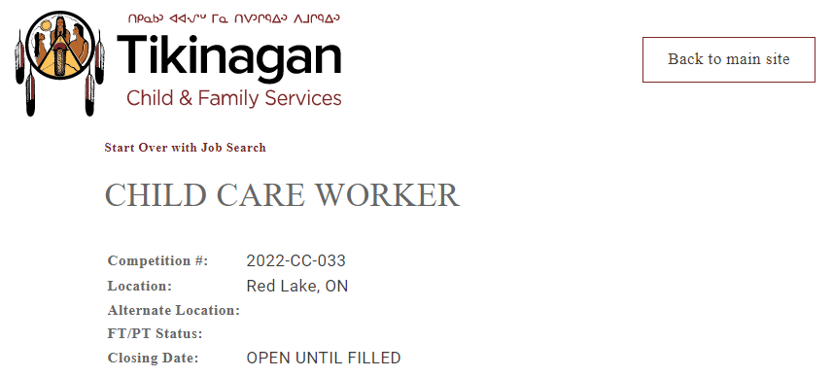**

**KOeHealth: UPDATED\***

### [e-Health Secretary](https://recruiting.ultipro.ca/KEE5000NCC/JobBoard/0f7cbf31-f68f-4b9a-a175-34c1162ee91c/OpportunityDetail?opportunityId=ad87ee0a-1f79-424e-86b3-db20c33571df)

### [Health Administration Support Worker](https://recruiting.ultipro.ca/KEE5000NCC/JobBoard/0f7cbf31-f68f-4b9a-a175-34c1162ee91c/OpportunityDetail?opportunityId=64961fa8-fdd9-4a44-b00b-aa6e806713fb)

### [Virtual Care Educator](https://recruiting.ultipro.ca/KEE5000NCC/JobBoard/0f7cbf31-f68f-4b9a-a175-34c1162ee91c/OpportunityDetail?opportunityId=b8a42625-f665-40e2-b373-46aa4e3bd742)

### [eHealth Data Analyst](https://recruiting.ultipro.ca/KEE5000NCC/JobBoard/0f7cbf31-f68f-4b9a-a175-34c1162ee91c/OpportunityDetail?opportunityId=8bda8277-b2ea-42ab-8872-b8b147ce7afb)

**For more information please click on the position above or visit** [www.kochiefs.ca](http://www.kochiefs.ca)

**SUPER 8:**

Super 8 Red Lake is looking to **hire 2 full time or part time housekeeping positions.**

Housekeeping staff is responsible for the cleanliness of the entire property.

Daily tasks will be assigned by the housekeeping supervisor/manager.

Daily tasks will include but not limited to:

1. Cleaning/preparing guest rooms for check in with the brand standard.

2. Vacuuming hallways, wiping down light fixtures

3. Sweeping/mopping lobby and other areas

4. Assisting front desk staff with meeting rooms set up, cleaning

5. Performing deep cleaning in guest rooms

6. Cleaning public restrooms

7. Washing, drying and folding linens and towels

Willing to train the right candidate and pay is negotiable.

**Guest Service Representative:** **Full time/ Part time**

Primary duties of guest service representative will include but not limited to:

- Providing friendly and courteous service to all patrons

- Answering phone calls to provide information about the property, availability, to process new reservations, update existing reservations and providing information about service and amenities offered

- Providing information about local attractions and businesses

- Processing payment accurately as per company policies

- Assisting guests with special requests

- Working closely with other departments to ensure smooth operation

- Keeping front office and lobby areas clean and tidy

- And any other tasks assigned by supervisor/Manager

Candidates must possess a friendly attitude who can multitask in a busy environment. Must also possess good phone etiquette, good communication skills, good computer skills. Flexibility to work both weekdays and weekends must.

Preference will be given to candidates with experience. However, willing to train the right candidate.

Starting pay will be $17.50. Pay can be negotiated for candidates with prior experience in the hotel industry.

**Breakfast Attendant:** **Part Time**

We are looking for a part time breakfast attendant to work 2 shifts in a week. Some of the breakfast attendant duties will include but not limited to:

- Setting up breakfast station at 4.30 in the morning for guests.

- Cooking eggs and breakfast meats

- Brewing coffees and replenishing juices

- Baking muffins and preparing waffle batter

- Keeping the kitchen and breakfast room clean and tidy.

- Following all food safety protocols

- Washing dishes

- Providing friendly service to all patrons

Willing to cover more than 2 shifts in a week occasionally as required. Shift usually starts at 4.30 AM and end time varies. Training will be provided.

Starting pay will be $17.00 per hour.

Drop off the resume at Super 8 Red Lake or email to [barth.super8redlake@gmail.com](mailto:barth.super8redlake@gmail.com)

**TRILLIUM GOLD:** 

Trillium Gold Mines Inc. is looking for two self-motivated individuals to join our dynamic team of professional geologists and technicians in the role of Geotechnician. Reporting to the Site Geologist, your primary duty will be to provide geotechnical support to the core logging geologists in the core shack. You will work in a fast-paced yet rewarding environment. Schedule one week on, one week off (town location), 2-3 weeks on, 1-2 weeks off (camp location).

**Responsibilities:**

* Commitment to workplace safety
* Measuring, aligning, and meter marking drill core
* Core orientation
* Core photography
* Magnetic susceptibility data measurements and data entry
* Preparing rock sample shipments and required documentation
* Data entry, record keeping, and reporting as required using a computer
* Core cutting and sampling as required
* Camp duties as required

**Qualifications:**

* Ability to complete a variety of tasks with minimal supervision
* Willing to work with a diverse team of professional geologists and technicians
* Ability to work in a fast-paced environment
* Ability to use a computer for data entry and shipping forms preferred but not required, training will be provided
* Previous experience preferred but not required, training will be provided
* Must be able to lift 50lbs and stand for long periods of time
* Drivers license preferred but not required
* Mechanical abilities, familiarity with ATVs and generators is an advantage
* Willingness to work either in Balmertown or at a camp location 1.5 hr from Balmertown

**About Trillium Gold**

Trillium Gold Mines Inc. is exclusively dedicated to the exploration and development of high-grade gold deposits in the Red Lake District, one of the premier mining areas in the world. Our experienced leadership and technical teams know the area like few do. Modern exploration and mining require modern approaches, and Trillium holds the values of sustainability at the core of its operations. Through these strategies, we are working to deliver long-term shareholder value whilst holding environmental and socially responsible matters paramount, which in turn produces strong community networks and reduces impacts on the local ecosystems.

**Ways to Apply**

Contact Samuel Lewis by phone at 204-228-3747, by email at [slewis@trilliumgold.com](mailto:slewis@trilliumgold.com), or submit your resume in person at 13 5th St Balmertown, Trillium Gold Mines Inc. office.

***Thank you for your application, however, only those selected for an interview will be contacted.***

**RED LAKE INDIAN FRIENDSHIP CENTRE: UPDATED** 

**Financial Administrator:**

The Financial Administrator will be required to provide oversight and supervision to staff reporting directly. Responsibilities will include monitoring of accounts payables and receivables. Ensure invoices are issued promptly. Prepare monthly, quarterly & annual reports for submission to the Board of Directors and funding agencies as required. These will include, but not be limited to annual cash flows, monthly bank reconciliations, monthly and quarterly income statements and financial reports.

Assist in the preparation of program budgets and grant writing proposals.

Provide recommendations for improvements including processes, systems and policy that safeguard the assets of the non-profit charity. Willingness to participate in training as required.

**Homelessness Outreach Worker:**

The Homelessness Outreach program provides a range of services and supports for Indigenous individuals to aid in preventing homelessness while ensuring that individuals have access to the necessary tools to assist themselves. The program will promote access to life skills, job readiness, health and cultural supports. This program provides a continuum of supports while coordinating a community driven approach to addressing homelessness in Red Lake. The Homelessness Outreach Worker will advocate for individuals and families with employment assistance workers, landlords, hotel managers and others, as required support during housing search process. Will also offer assistance with connecting to community resources, such as income and rental assistance.

**Supportive Housing Coordinator: (Kaabeshiwiin - Part Time- 1 Year Contract ending March 31, 2023)**

Responsible for completing intake and review process with prospective clients; Provide light support to tenants involved in the program, including, but not limited to home maintenance, budgeting, cooking and other basic life skills; Responsible for preparing program reports, monthly quarterly, annually as per contract; Ability to complete monthly subsidies and arrears payments in a timely manner, ensuring all applications are complete; Excellent computer skills

**Akwe:go:**

**The Akwe:go program is grounded in cultural traditions providing a sense of belonging for urban Indigenous children ages 7 – 12.**The program offers a variety of strategies such as one-to-one activities, group activities, and family circles to encourage positive behaviours and wellbeing. The program supports individualized goals to enhance the child’s area of need; supporting social skills, educational intervention, individuals with disabilities, violence prevention, children in care or at risk of being in the care of the Children’s Aid Society, 2SLGBTQ+ supports, and positive nutrition and physical activity practices. The Akwe:go program provides a space where urban Indigenous children can feel safe to be themselves and accepted.

**Driver: (Part-time)**

Must be flexible to meet the needs of program staff. Able to run errands, ability to lift up to 50 lbs. max. Clean Driving record with proof of previous fleet insurance coverage is essential. Ability to work independently as well as in a group setting.

**FAS/D Community Support Worker:**

To assist in the preparation, articulation and implementation of a nutrition and FAS/FAE strategies and resources for the Centre. Facilitate educational presentations, workshops and community outreach for individuals and agencies affected by FAS/FAE. Implement schedule of programs and services for those affected by FAS/FAE. Provide advocacy and referrals for clients registered with the program.

**Urban Aboriginal Healthy Living Program Coordinator: (Maternity Leave 1 Year Contract ending July 16, 2023)**

The coordinator is responsible to design, develop, coordinate, facilitate, monitor and evaluate healthy lifestyle programs based on community needs and interests. The coordinator will ensure that program design and delivery, complies with all Friendship Centre and OFIFC standards of performance and that all program requirements are attained. Plan, organize, supervise, assess and facilitate physical fitness and recreation programs; sport activities, healthy eating and weight management programs, youth leadership and smoking cessation programs appropriate for participant knowledge base and physical capabilities.

**Qualifications - All Positions:**

* Post-secondary degree/diploma in Social/Human Services, Indigenous Studies or equivalent training combined with relevant work experience
* Valid Ontario Driver’s License & access to a vehicle
* Ability to speak, read & write an indigenous language an asset
* Must be able to provide a satisfactory Vulnerable Sector Check
* Provide or able to obtain First Aid/CPR, WHMIS & Safe Food Handling Certification
* Participate in training as required.

**Deadline:** Open till filled

Interested Candidates should submit their resume & 3 references to:

Peter Campbell

Executive Director

Red Lake Indian Friendship Centre

P. O. Box 244

Red Lake, ON P0V 2M0

[director@rlifc.ca](mailto:director@rlifc.ca)

**EAR FALLS**

**EMCON SERVICES: NEW\*\*\***

* General Laborer Seasonal
* Maintenance Operator- Trainee Seasonal
* Maintenance Operator- Trainee Seasonal
* Winter Seasonal Maintenance Operator (2 openings)

**Please visit** [**EMCON**](https://www.emconservices.ca/jobs-ontario.html) **for more information and to apply.**

cid:image001.png@01D85977.47FCA6B0 **Recruiting for Interfor, Ear Falls…**

|  |  |
| --- | --- |
| [Maintenance Superintendant](https://hlctalent.catsone.com/careers/22790-HLC-TALENT/jobs/15372774-Maintenance-Superintendant/) | [Inventory Coordinator](https://hlctalent.catsone.com/careers/22790-HLC-TALENT/jobs/14887141-Inventory-Coordinator/) |
| [Human Resources Manager](https://hlctalent.catsone.com/careers/22790-HLC-TALENT/jobs/15319224-Human-Resources-Manager/) | [Industrial Electrician](https://hlctalent.catsone.com/careers/22790-HLC-TALENT/jobs/14868781-Industrial-Electrician/) |
| [Millwright](https://hlctalent.catsone.com/careers/22790-HLC-TALENT/jobs/15060193-Millwright/) | [Heavy-Duty Equipment Mechanic](https://hlctalent.catsone.com/careers/22790-HLC-TALENT/jobs/14856502-HeavyDuty-Equipment-Mechanic/) |
| [Operations Forester](https://hlctalent.catsone.com/careers/22790-HLC-TALENT/jobs/14887600-Operations-Forester/) | [Production Technician](https://hlctalent.catsone.com/careers/22790-HLC-TALENT/jobs/14854198-Production-Technician/) |

**For more information visit:** [For more HLC Talent click here](https://linktr.ee/hlctalent)

**KENORA DISTRICT SERVICES BOARD**

**For more information, to see full job descriptions on each position and to apply please visit:** [**https://kdsb.on.ca/join-our-team/**](https://kdsb.on.ca/join-our-team/) **or click on the position below…**

[***Temporary, Full-Time Integrated Services Worker – Open to the District***](https://kdsb.on.ca/jobs/temporary-full-time-integrated-services-worker-open-to-the-district/)

[***Two (2) Temporary, Part-Time Registered ECE’s or ECE Assistants – Red Lake***](https://kdsb.on.ca/jobs/11724/)

[***One (1) Regular, Full-Time Early Years Quality Assurance Coordinator – Red Lake***](https://kdsb.on.ca/jobs/one-1-regular-full-time-early-years-quality-assurance-coordinator-red-lake-2/)

[***Temporary, Part-Time Shelter Attendant – Red Lake***](https://kdsb.on.ca/jobs/temporary-part-time-shelter-attendant-red-lake-2/)

[***Temporary, Part-Time Weekend Day Shift Shelter Attendant – Red Lake***](https://kdsb.on.ca/jobs/temporary-part-time-weekend-day-shift-shelter-attendant-red-lake/)

[***One (1) Temporary, Full-Time EarlyON Child and Family Centre Coordinator – Red Lake***](https://kdsb.on.ca/jobs/one-1-temporary-full-time-earlyon-child-and-family-centre-coordinator-red-lake/)

[***Temporary Part-Time Shelter Attendant – Red Lake***](https://kdsb.on.ca/jobs/temporary-part-time-shelter-attendant-red-lake/)

[***Temporary Full-Time Shelter Attendant – Red Lake***](https://kdsb.on.ca/jobs/temporary-full-time-shelter-attendant-red-lake/)

[***Permanent, Full-Time, Registered ECEs or ECE Assistants – Red Lake***](https://kdsb.on.ca/jobs/permanent-full-time-registered-eces-or-ece-assistants-red-lake/)

[***Casual Registered ECEs/ECE Assistants – Red Lake***](https://kdsb.on.ca/jobs/casual-registered-eces-ece-assistants-red-lake/)

[***Casual Registered ECEs/ECE Assistants – Ear Falls***](https://kdsb.on.ca/jobs/casual-registered-eces-ece-assistants-ear-falls-4/)

**KEEWATIN PATRICIA DISTICT SCHOOL BOARD:**

**Part Time Custodian**

Please visit for more information: <http://www.kpdsb.on.ca/pages/view/employment-opportunities>

**-END-**