P.O. Box 223 / 146 Howey Street Red Lake, ON P0V 2M0
www.redlakejobs.ca / redlakejobs@shaw.ca
Tel: (807) 727-2297 / Fax: (807) 727-1176
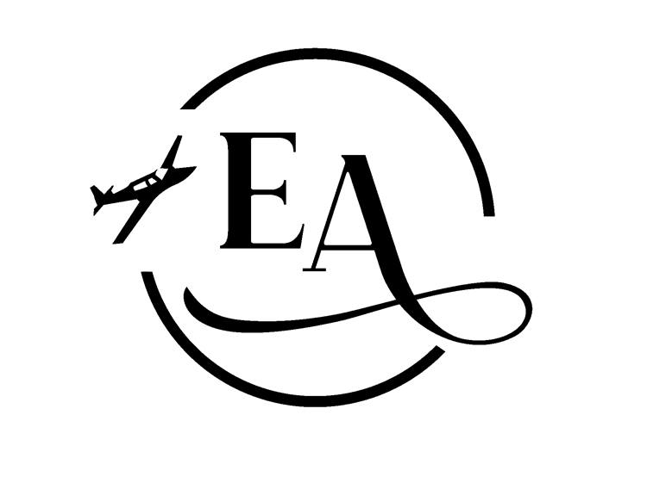
Seasonal Employment – May 25th, 2022
EXCELLENT ADVENTURES
Administrative Assistant
Seeking an office admin assistant, position to begin immediately.
- Current resume and references.
- Must have proof of criminal record & Driving record.
- Willing to do a minimal amount of training.
- Computer skills a must.
- Energetic and a positive outlook.
- Excellent attention to detail
Person must be able to follow company policies. Able to manage flight bookings and keep track of our warehouse inventory. This person should have good computer skills and excellent communication skills.
We are also looking for someone that is flexible for weekend shifts as well.
For more information, Contact 807-662-5292
Email office@exc-adventures.com

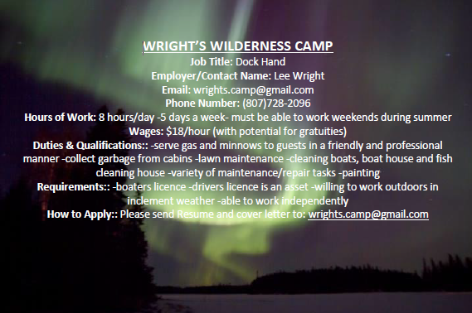

Core Cutter/Helper
Summer Drilling Position located on Forestry RD. Must be local and have a valid driver’s license. End of May/June start. May be a potential spot for a summer student.
To apply send resume to mtimmins@solisticegold.com

LCBO
Customer Service Representative Part-Time
We are looking for Seasonal Customer Service Representatives to work between May 2nd and September 5th (Labour Day). With your outgoing personality and excellent customer service, together we will build a lasting impression that our customers will take with them … along with their purchase.
If this resonates, then we would love to have you join our team! As an LCBO CSR, you'll have a chance to inspire others, reach your full potential and share your knowledge with our customers. Learn more about wine, beer, ciders and spirits than you ever imagined as you get paid for up to 12 hours of online training, including product knowledge essentials.
About the Role:
- Serve customers using our POS/Cash system, promptly, courteously and responsibly, ensuring an outstanding customer experience
- Ask for donations as part of our Spirit of Sustainability campaign
- Participate in the Customer Experience and Postal Code Survey campaigns
- Receive inventory, replenish stock, face-up products on shelves and ensure our store is clean, organized and safe for all (clean up spills and broken bottles)
- Perform job duties that occasionally involve repeatedly lifting cases varying in size and weight (up to 60 lbs./27 kg), while standing continuously
- $16.58 per hours part-time position
About You:
- Phenomenal interpersonal and engagement skills
- Must be eligible to work in Canada (valid SIN, Student or Work Permit)
- Minimum of 18 years of age
- Full COVID-19 vaccination is a required condition of employment (first and second dose)
- Bilingualism (English and French) is a bonus
Required Availability
- Friday (5:00 p.m. – Close)
- Saturday and Sunday (available all day for a 4 - 8 hour shift)
Long Weekends
- Victoria Day (May 20 – 23)
- Canada Day (June 30 – July 3)
- Civic Holiday (July 29 – August 2)
- Labour Day (September 1 – September 4)
Additional Availability
- Additional work is available during the week (Monday - Thursday) based on each store's operational requirements
- Schedules are posted two weeks in advance and on occasion, shifts are available on short notice
There is a world of opportunities at the LCBO…
We foster an environment of inclusion and belonging, so everyone feels valued, respected, and heard. The LCBO is an equal opportunity employer and committed to providing employment accommodation in accordance with the Ontario Human Rights Code and the Accessibility of Ontarians with Disabilities Act. If contacted for an interview or employment opportunity, please advise if you require an accommodation.

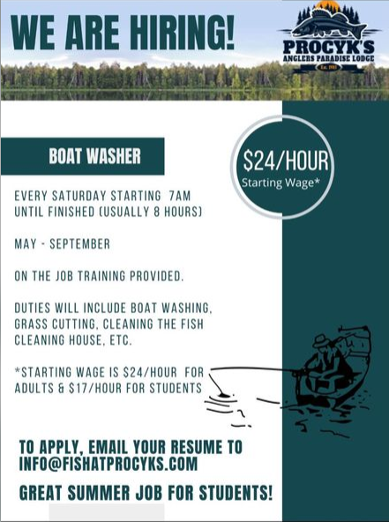

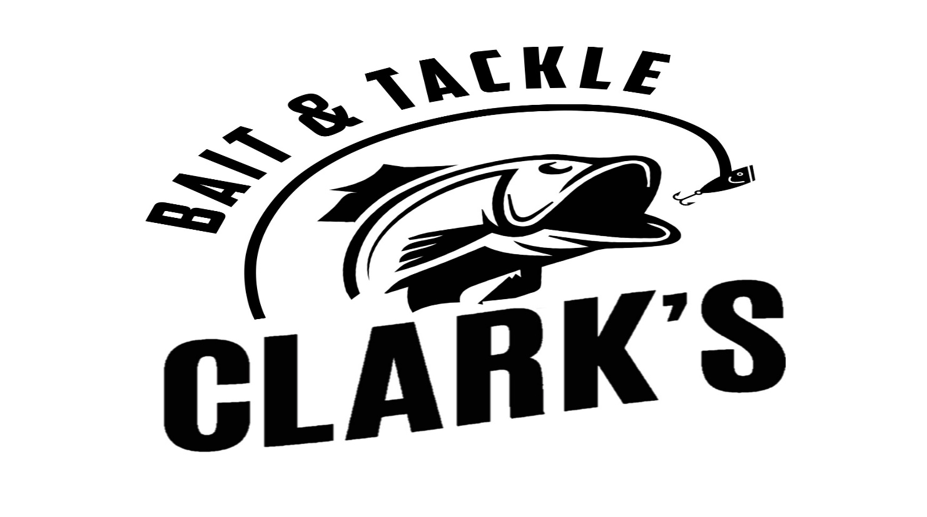
CLARKS HOWEY STREET:
- (2) Part -time at Red Lake Location
- Full-time; starting wage $18.00/hour
- Customer service; sales of bait and convenience store items; monitor docking.
- Students welcome to apply; $15.00/hour.
To apply: Send resume to info@clarksresorts.com / drop off at Howey Street location.

Our lodge is located 52km up the Nungesser Road off the HWY 125 between Balmertown and Cochenour. We are a remote drive to, boat in lodge. We currently have a dockhand and a cabin cleaner position available for our 2022 season. Couples encouraged for cabin cleaner and dock hand positions. Season runs from May until September; we provide you with room and board, as well provide competitive wages, gratuities from the guests are in addition to your wages.
Cabin Cleaner
Required Thursday, Friday, and Saturdays.
Fridays are our change over day, our guests leave early in the morning and new guests start to arrive at 1pm.
Duties for full-time cleaner will extend to daily help on docks, meal preparations for staff, painting, etc. as needed.
- Be able to multitask and work quickly and efficiently.
-Have strong attention to detail
Please contact Matt or Janelle Kehoe for more information.
Phone: 1-807-735-2053
Send resume and references to info@nungesserlake.com

SANDY BEACH LODGE
We are looking for versatile and friendly individuals for our upcoming fishing season at Sandy Beach Lodge. The individuals we are seeking may serve in the dining room during breakfast and dinner hours as well as help with daily Lodge and cabin clean up. We work as a team our jobs involve any kind of housekeeping cleaning, laundry dishes vacuuming making beds, and serving in the dining room. Our wages start at 15 dollars an hr plus shared tips. Also, your room and board are included. In our spare time which is usually between 12 and 5, we can swim kayak, and also go fishing or practice golf on our one-hole golf course. Sandy Beach lodge is located on Trout Lake in Northern Ontario and is a fly-in destination. If you like the outdoors and camp-like surroundings and don't mind a little hard work this is a great way to spend a summer and save a little bit of money. Looking forward to hearing from you.
Anke Fiene (715) 339-6636 or email ankefiene@hotmail.com

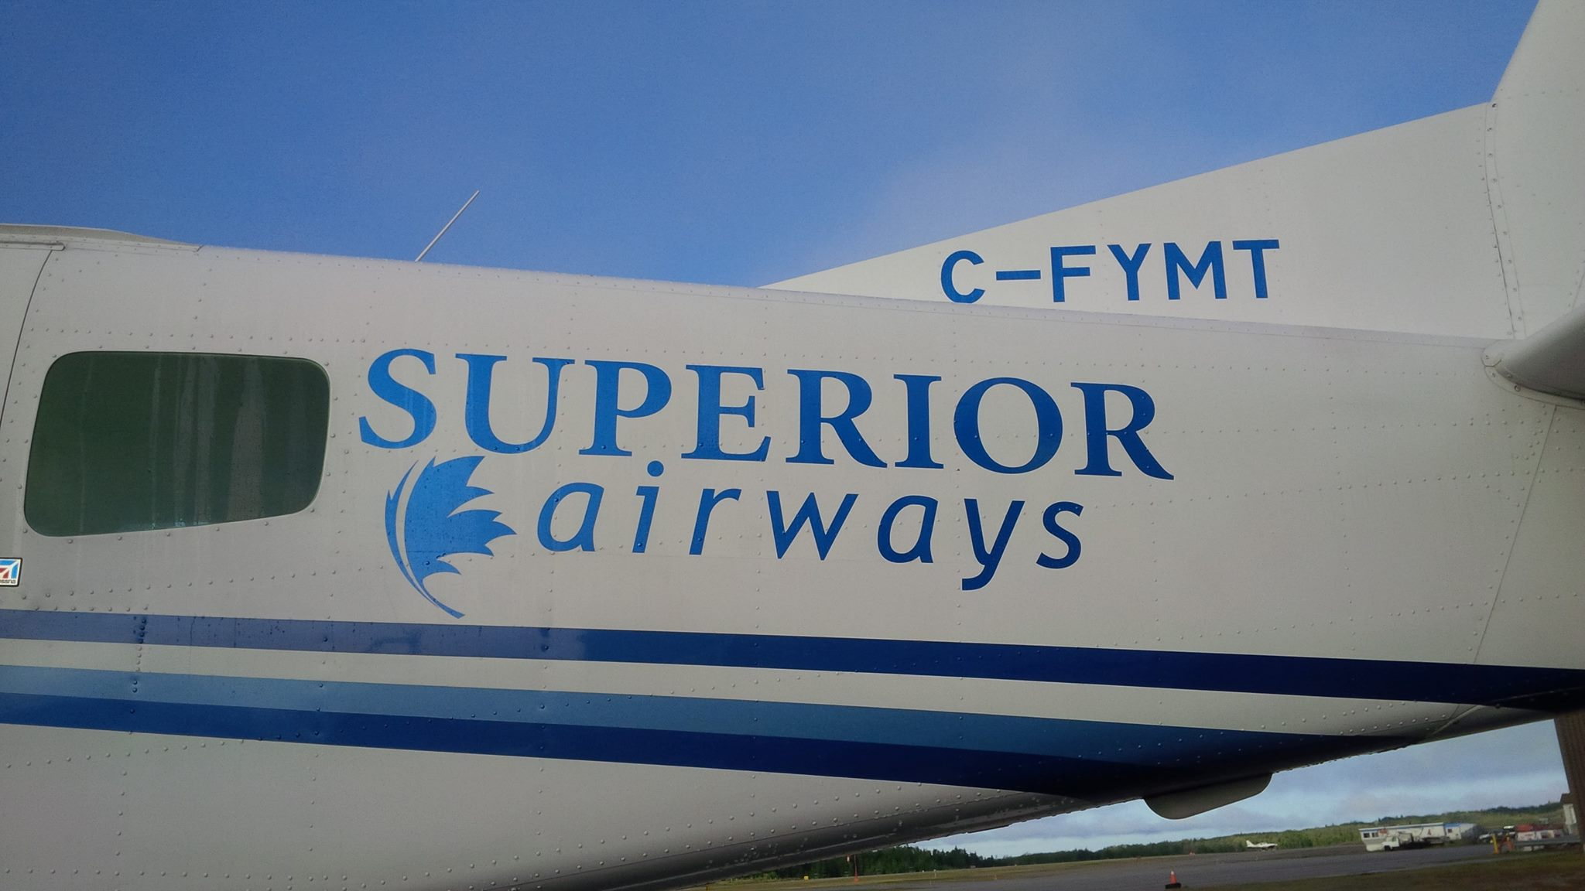
SUPERIOR AIRWAYS
Seasonal Dockhand
Superior Airways Seaplane Base in Red Lake. This is an excellent opportunity for those who love to work outdoors in a fast paced, friendly environment.
Duties include, but are not limited to: loading/unloading aircraft, receiving freight, general cleaning of aircraft, parking customer vehicles.
REQUIREMENTS
Previous customer service experience an asset
Valid drivers license required
Warehouse experience and asset
Successful candidate may be required to provide a Criminal Reference Check
Schedule to be discussed Full-time position at $18 an hour
Submit resumes to: subject line “Dock Hand” Careers@superiorairways.com

The Red Lake Golf & Country Club is looking for fun, energetic and reliable workers for the following positions
• Kitchen Manager
• Club House Manager
• Pro Shop Attendant
• Prep Cooks
• Clubhouse Staff
Please email your resume to golfredlake@golfredlake.com
