# RLCES_Logo2EO-LogoTag-Eng_BW_revEO-LogoTag-Fr_BW_rev

# P.O. Box 223 / 146 Howey Street Red Lake, ON P0V 2M0

[**www.redlakejobs.ca**](http://www.redlakejobs@shaw.ca) **/** [**redlakejobs@shaw.ca**](mailto:redlakejobs@shaw.ca)

Tel: (807) 727-2297 / Fax: (807) 727-1176

# Job Postings for the Red Lake/Ear Falls area

**May 25th, 2022**

**\*\*\* Check out our new “Summer/ Seasonal Jobs List” on our website! \*\*\***

**RED LAKE**

**KINROSS: Great Bear Resources: NEW\*\*\* **

|  |  |
| --- | --- |
| [**Core Logging Geologist**](https://jobs.kinross.com/job/Red-Lake-Core-Logging-Geologist-Onta/885876600/) | Red Lake, Ontario, Canada |
| [**Safety & Training Superintendent**](https://jobs.kinross.com/job/Red-Lake-Safety-&-Training-Superintenden-Onta/868477100/) | Red Lake, Ontario, Canada |
| [**Senior Database Administrator**](https://jobs.kinross.com/job/Red-Lake-Senior-Database-Administrator-Onta/887784500/) | Red Lake, Ontario, Canada |
| [**Environmental Technician**](https://jobs.kinross.com/job/Red-Lake-Environmental-Technician-Onta/887785300/) | Red Lake, Ontario, Canada |
| [**Site Administration Assistant**](https://jobs.kinross.com/job/Red-Lake-Site-Administration-Assistant-Onta/887791600/) | Red Lake, Ontario, Canada |
| [**Environmental Coordinator**](https://jobs.kinross.com/job/Red-Lake-Environmental-Coordinator-Onta/877370800/) | Red Lake, Ontario, Canada |
| [**Summer Student**](https://jobs.kinross.com/job/Red-Lake-Summer-Student-Onta/877372800/) | Red Lake, Ontario, Canada |

Apply to: [Careers at Great Bear Resources A Kinross Company](https://www.kinross.com/careers/)

WASAYA: NEW\*\*\* 

Positions available:

* [Station Coordinator](https://wasaya.com/careers/current-opportunites/station-coordinator/)
* [Ramp Attendant- Red Lake](https://wasaya.com/careers/current-opportunites/ramp-attendant-red-lake/)
  + For more job opportunities and information please visit <http://wasaya.com/careers/>

**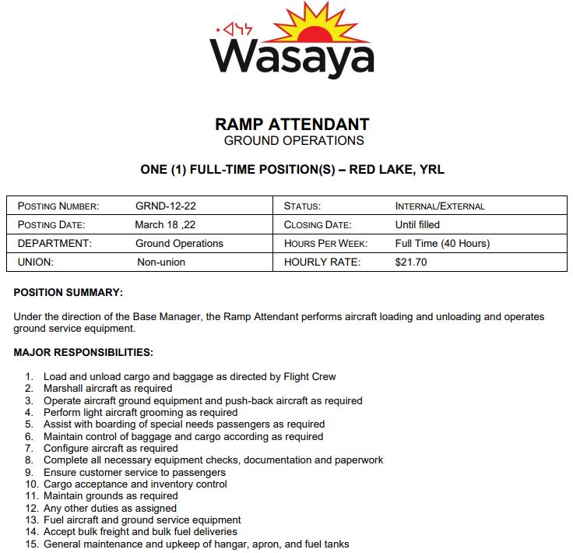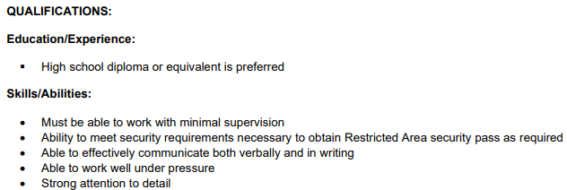**

**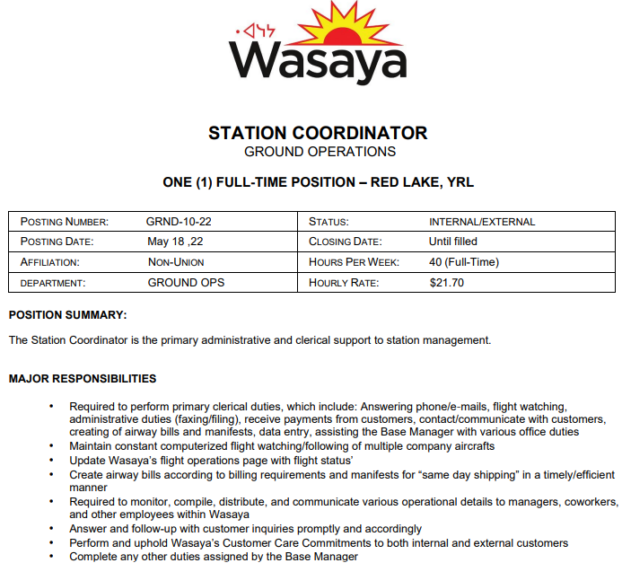** **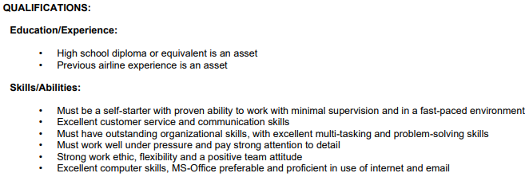** 

**KOeHealth: NEW\*\*\***

**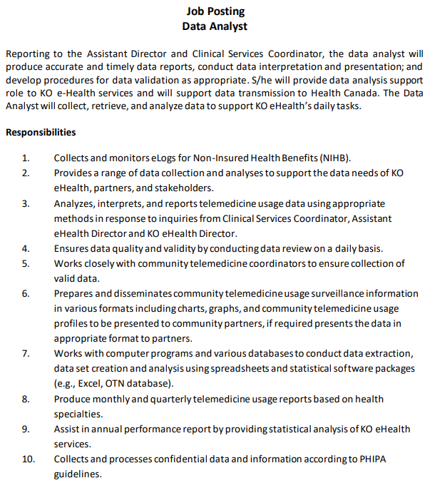**

**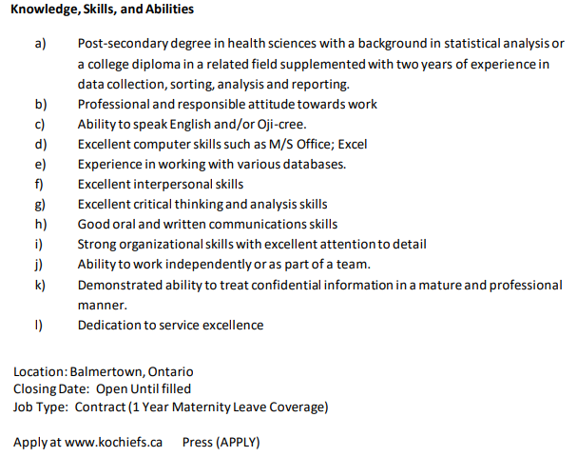**

**NGI: NEW\*\*\***

**Receptionist**

Job Description: Responsibilities include: Delivering exceptional customer service, this entails; answering calls and fielding them accordingly, addressing questions and needs, and providing an overall welcoming environment.

Responsibilities:

* Greet and welcome guests as soon as they arrive at the office
* Answer, screen and forward incoming phone calls
* Ensure reception area is tidy and presentable
* Provide basic and accurate information in-person and via phone/ email
* Receive, sort and distribute daily mail/ deliveries
* Update calendars and schedule meetings
* Perform other clerical receptionist duties such as filing, photocopying, transcribing, faxing and other duties as directed by Management

Qualifications

* Proven work experience as a receptionist, Front Office Representative or similar role
* Proficiency in Microsoft Office
* Hands-on experience with office equipment (e.g. fax machines and printer)
* Professional attitude and appearance
* Solid written and verbal communication skills
* Ability to be resourceful and proactive when issues arise
* Excellent organizational skills
* Multitasking and time-management skills, with the ability to prioritize tasks
* Positive attitude

Apply by email [accounts@ngiredlake.com](mailto:accounts@ngiredlake.com) or you can drop off a resume in person at 192 Howey street.

**ANTONIO’S: NEW\*\*\***

**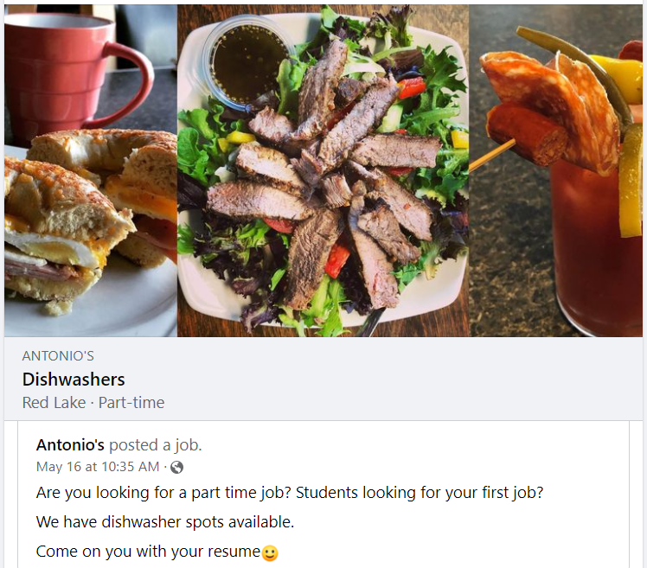**

**NORTHWOOD LODGE: NEW\*\*\***

****

**SUBWAY: NEW\*\*\***

**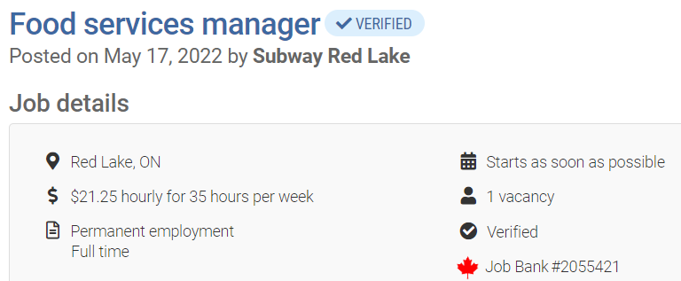**

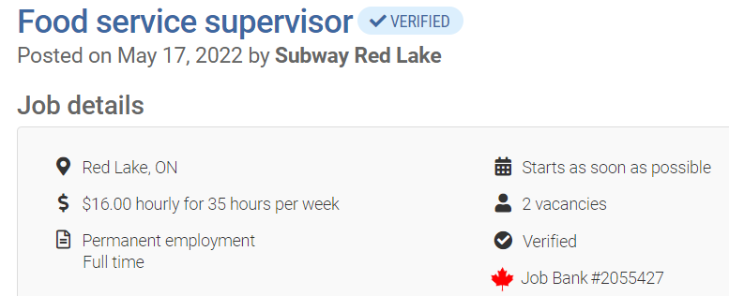

Apply by email or in store: [subwayredlake@yahoo.com](mailto:subwayredlake@yahoo.com)

Position will be advertised until 2022/06/16

**EECOL: NEW\*\*\***

About the Job…This is an entry-level warehouse position. A typical day includes:  
  
- Preparing goods for shipment  
- Arranging for shipment pick-ups  
- Loading/unloading trucks  
- Picking items to fill orders  
- Checking goods received, putting stock away  
- General warehouse/yard organization  
- Cutting, spooling wire  
- Operating forklift, pallet jacks  
- Assisting customers with inquiries  
\*Safety footwear is a requirement for all warehouse positions.

Apply by email [Ron.Demeduk@eecol.com](mailto:Ron.Demeduk@eecol.com) or in store.

**RED LAKE MEMORIAL HOSPITAL: UPDATED** 

|  |  |  |  |
| --- | --- | --- | --- |
| **Job Title** | **Closing Date** | **Department** | **Employment Status** |
| [Housekeeper](https://www.redlakehospital.ca/uploads/Common/Housekeeper%20Casual%20External%20no%20end%20date.pdf) | When Filled | Housekeeping | Casual |
| [Registered Nurse](https://www.redlakehospital.ca/uploads/Common/RN%20External%20September%20II.pdf) (2) | When Filled | Nursing | Permanent, Part-Time & Temporary, Part-Time |
| Casual Cook/  Dietary aid | When Filled |  |  |

**Visit the Hospitals website for updated information:** [**Hospital Jobs**](https://www.redlakehospital.ca/currentopportunities)

**CLARK’S CORNER GAS: Updated**

**Customer Service**

Red Lake Location:

* 2 Part-time/ casual positions; must be flexible for available shifts; summer operating hours could vary; wage to be determined.
* Students welcome to apply; $15.00/hour.
* Handle payments; customer service in convenience store; product display.

Balmertown Location:

* Full-time; must be flexible for available shifts; summer operating hours 6 am – 10 pm; wage to be determined.
* Students welcome to apply; $15.00/hour.
* Gas attendant; handle payments; customer service in convenience store; product display.

Cochenour Location:

* Full-time; starting wage $18.00/hour; start May 15/22.
* Customer service; sales of bait and convenience store items; monitor docking.
* Students welcome to apply; $15.00/hour.

**To apply:** Send resume to [info@clarksresorts.com](mailto:info@clarksresorts.com) / drop off at Howey Street location

**EVOLUTION MINING: NEW\*\*\***

|  |  |
| --- | --- |
| [Vacation Student - Rock Mechanic (Co-Op Placement)](https://careers.evolutionmining.com.au/job/Red-Lake-Vacation-Student-Rock-Mechanic-%28Co-Op-Placement%29-ON/776420210/) | [Senior Geologist - Resource Definition](https://careers.evolutionmining.com.au/job/Red-Lake-Senior-Geologist-Resource-Definition-ON/588704210/) |
| [Superintendent - Rock Mechanics](https://careers.evolutionmining.com.au/job/Red-Lake-Senior-Rock-Mechanic-%28Geotechnical-Engineer%29-ON/774620010/) | [IT Administrator - Systems Support](https://careers.evolutionmining.com.au/job/Red-Lake-IT-Administrator-Systems-Support-ON/772092210/) |
| [Mine Surveyor](https://careers.evolutionmining.com.au/job/Red-Lake-Mine-Surveyor-ON/774772110/) | [Senior Geologist - Mine](https://careers.evolutionmining.com.au/job/Red-Lake-Senior-Geologist-Mine-ON/587671610/) |
| [Drill and Blast Coordinator](https://careers.evolutionmining.com.au/job/Red-Lake-Drill-and-Blast-Coordinator-ON/589190210/) | [Geologist - Exploration](https://careers.evolutionmining.com.au/job/Red-Lake-Geologist-Exploration-ON/588833110/) |

**Apply to/Full Job Descriptions:** [Careers at Evolution Mining Limited](https://careers.evolutionmining.com.au/search/?q=&q2=&alertId=&locationsearch=&title=&location=red+lake&date=)

**BALMERTOWN FOOD FAIR:**

We are hiring for the following positions:

|  |  |  |
| --- | --- | --- |
| **Produce Clerk:**  32 - 40 hours per week Start date: right away  Pay: dependent on experience Experience is an asset | **Cashier:** 32 - 40 hours per week Start date: right away Pay dependent on experience Experience is an asset | **Grocery Clerk:** 40 hours per week Start date: right away Pay dependent on experience Experience is an asset |

For all of the positions experience is an asset, but not a requirement. We will train individuals that do not have experience in the job listing. We ask that they have a willingness to learn and to work as a team with all of our team members.

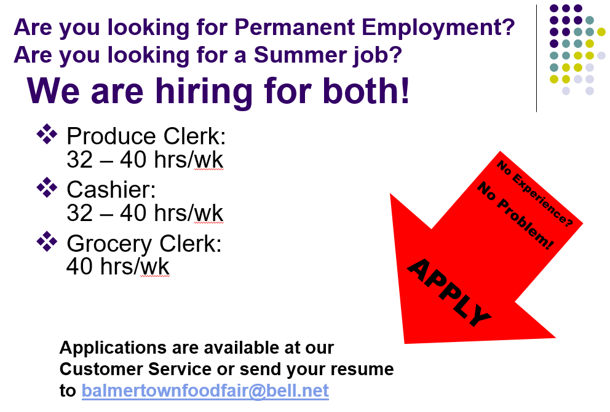

NEW STARTS WOMEN SHELTER: NEW\*\*\*

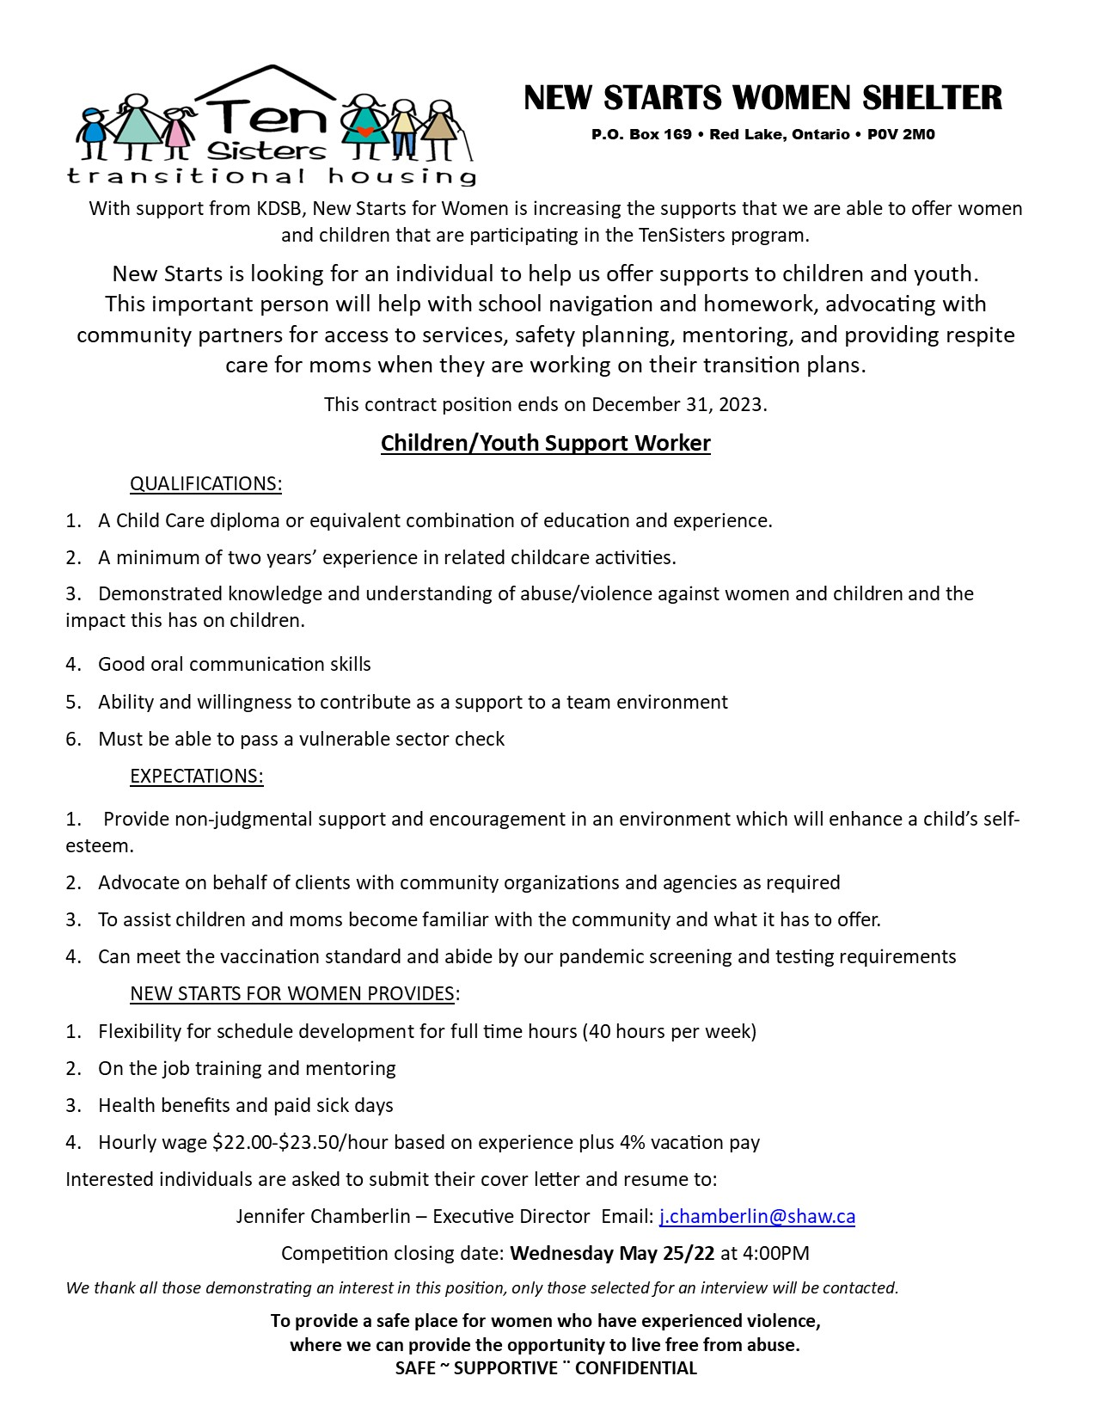

**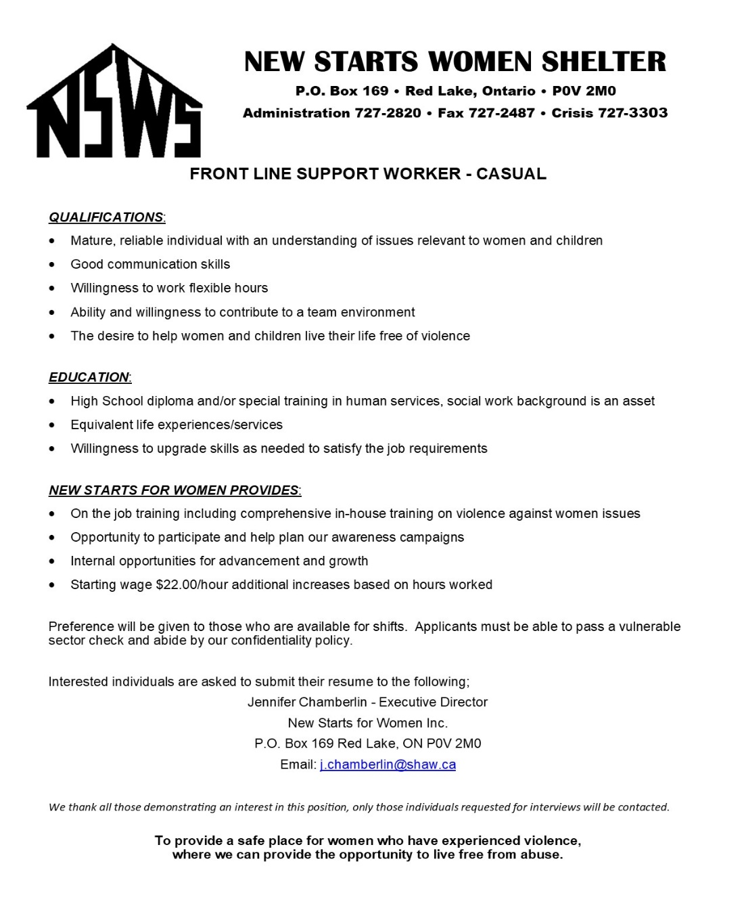**

**RED LAKE HERITAGE CENTRE: NEW \*\*\***

|  |  |
| --- | --- |
| Job Title: | Tourism Docent |
| Employer/Contact Name: | Trevor Osmond |
| Location/Address: | 51A Highway 105 |
| Application Deadline: | June 25, 2022 |
| Email: | [heritage@redlake.ca](mailto:heritage@redlake.ca) |
| Phone Number: | 1 (807) 727-3006 |
| Hours of Work: | 7.25 per day, 9 to 5 |
| Wages: | $15/hour |
| Duties & Qualifications:: | Skills: Customer service, tourism knowledge, communication skills Work Setting: Museum, Tourism Centre Objectives: Increase the RLRHC's visitor experience by - Greeting visitors, and provide visitors with tourism information, answering questions about the region. Ensure the RLRHC's Tourism information is up to date by: Meeting with the Highway 105 Tourism Board, Travelling to the tourism camps, Restocking brochures, Communicating with local businesses Increase awareness of the RLRHC by posting on social media - Creating Facebook posts, Photographing the RLRHC and local tourism hot spots. Work with RLRHC on creating the On This Spot tourism experience application - Collect photographs, and create social media posts reaching out to the town for historical photographs, Communicate with Highway 105 Tourism Board, Communicate with the Municipality of Red Lake Must comply with the Sumer Experience Programs' hiring guidelines |
| Requirements:: | Education: In High school or college/university- Experience: None |
| How to Apply:: | In order to apply for the position of Tourism Docent, the applicant will be required to email their resume, and cover letter to [heritage@redlake.ca](mailto:heritage@redlake.ca) |
| Job Type:: | Summer- Full-time hours 36.5 |

**RED LAKE HERITAGE CENTRE:**

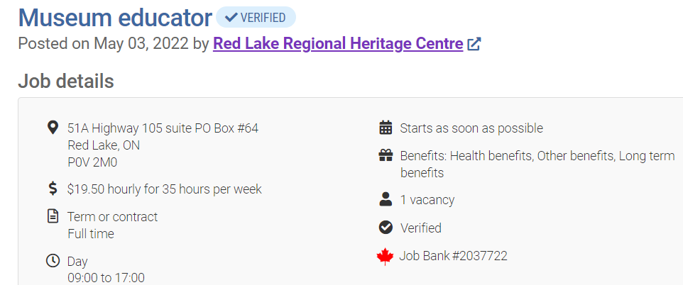

Apply be email: [heritage@redlake.ca](mailto:heritage@redlake.ca) include job reference number: RLRHC 8510360 and highest level of education and name of institution it was completed.

**TRILLIUM GOLD:** 

Trillium Gold Mines Inc. is looking for two self-motivated individuals to join our dynamic team of professional geologists and technicians in the role of Geotechnician. Reporting to the Site Geologist, your primary duty will be to provide geotechnical support to the core logging geologists in the core shack. You will work in a fast-paced yet rewarding environment. Schedule one week on, one week off (town location), 2-3 weeks on, 1-2 weeks off (camp location).

**Responsibilities:**

* Commitment to workplace safety
* Measuring, aligning, and meter marking drill core
* Core orientation
* Core photography
* Magnetic susceptibility data measurements and data entry
* Preparing rock sample shipments and required documentation
* Data entry, record keeping, and reporting as required using a computer
* Core cutting and sampling as required
* Camp duties as required

**Qualifications:**

* Ability to complete a variety of tasks with minimal supervision
* Willing to work with a diverse team of professional geologists and technicians
* Ability to work in a fast-paced environment
* Ability to use a computer for data entry and shipping forms preferred but not required, training will be provided
* Previous experience preferred but not required, training will be provided
* Must be able to lift 50lbs and stand for long periods of time
* Drivers license preferred but not required
* Mechanical abilities, familiarity with ATVs and generators is an advantage
* Willingness to work either in Balmertown or at a camp location 1.5 hr from Balmertown

**About Trillium Gold**

Trillium Gold Mines Inc. is exclusively dedicated to the exploration and development of high-grade gold deposits in the Red Lake District, one of the premier mining areas in the world. Our experienced leadership and technical teams know the area like few do. Modern exploration and mining require modern approaches, and Trillium holds the values of sustainability at the core of its operations. Through these strategies, we are working to deliver long-term shareholder value whilst holding environmental and socially responsible matters paramount, which in turn produces strong community networks and reduces impacts on the local ecosystems.

**Ways to Apply**

Contact Samuel Lewis by phone at 204-228-3747, by email at [slewis@trilliumgold.com](mailto:slewis@trilliumgold.com), or submit your resume in person at 13 5th St Balmertown, Trillium Gold Mines Inc. office.

***Thank you for your application, however, only those selected for an interview will be contacted.***

****

**Updated\***

**EXCELLENT ADVENTURES:**

**Administrative Assistant**

* Excellent adventures are seeking an office admin assistant. Position to begin immediately. Will discuss wages etc. in an interview. Would like to see a current resume and references. Must have proof of criminal record. Driving record as well. Willing to do a minimal amount of training. Computer skills a must. Person must be able to follow company policy’s. Energetic and a positive outlook.
* At Excellent adventures we are looking for someone that has excellent attention to detail and is reliable, who can manage flight bookings and keep track of our warehouse inventory. This person should have good computer skills and excellent communication skills. We are also looking for someone that is flexible for weekend shifts as well.

**Ramp Attendant: Full-Time NEW\*\*\***

* Offering full time work as an airport ramp attendant, located in Red Lake Ontario.
* Seeking an upbeat person with a good deposition, be in good physical health body and mind. Not afraid to take on a challenge when required.

Job description would entail the following:

* loading and unloading freight for aircraft
* preparing plane for clients
* must hold a valid driver’s license.
* assisting others if required,
* must be able to follow direction and at times use good judgment

We do provide accommodations fully furnished.

If you hold a pilot’s license this might be a good starting off place for someone who would like to advance in the aviation sector.

Would like at a minimum of a high school diploma, any credentials that would apply to this type of work. Previous experience an asset. Be able to think on your own when need be.

References required- at least 3, 2 for work and 1 personal

We have wheeled aircraft and well as float aircraft.

Job Types: Full-time, Permanent

Salary: From $25.00 per hour

Additional pay: Bonus pay

Benefits: Commuter benefits, Flexible schedule

Schedule:10-hour shift, Holidays, Monday to Friday, Weekends

Work remotely: No

**General Labourer NEW\*\*\***

Excellent Adventures is currently looking for a general labourer to work at our floatplane airbase in Cochenour, ON. Duties include but are not limited to loading and unloading vehicles and planes, assisting with warehouse inventory, and general maintenance.

The candidate must be able to work flexible hours and be physically fit. We are looking for someone who is reliable and trustworthy. Competitive wage, great work environment. Accommodations may be provided.

Please email resume to [office@exc-adventures.com](mailto:office@exc-adventures.com) Phone 807-662-5292.

**KEEWATIN PATRICIA DISTICT SCHOOL BOARD:** 

[Lunch Hour Supervisors](http://www.kpdsb.on.ca/assets/uploads/LHS%20ad%202021-2022.pdf)

[Dryden Regional Training and Cultural Centre](http://www.kpdsb.on.ca/assets/uploads/DRTCC.pdf)

[Tutors In The Classroom](http://www.kpdsb.on.ca/assets/uploads/Tutors%20In%20The%20Classroom%202021%20-%202022%20-%20Rev%20March%2011-22.pdf)

[Mental Health and Addictions Nurse - Red Lake](http://www.kpdsb.on.ca/assets/uploads/NW21-51_MHAN_Red_Lake_Ext.pdf)

|  |  |
| --- | --- |
| Job Title: | Full Time Elementary French Teacher |
| Employer/Contact: | Keewatin Patricia District School Board |
| Duties & Qualifications:: | The Keewatin-Patricia District School Board is seeking a Full Time Elementary French Teacher.  For complete details and / or to apply please visit our website at:  <http://www.kpdsb.on.ca/pages/view/employment-opportunities> |
| How to Apply:: | <http://www.kpdsb.on.ca/pages/view/employment-opportunities> |
| Job Type:: | Full Time |

Please visit for more information:

<http://www.kpdsb.on.ca/pages/view/employment-opportunities>



**KENORA DISTRICT SERVICES BOARD:**

**\*\*\*Please click the link below or click a specific job post to see full job descriptions for positions at KDSB:** [**https://kdsb.on.ca/join-our-team/**](https://kdsb.on.ca/join-our-team/)

[***One (1) Temporary, Full-Time EarlyON Child and Family Centre Coordinator – Red Lake***](https://kdsb.on.ca/jobs/one-1-temporary-full-time-earlyon-child-and-family-centre-coordinator-red-lake/)

[***Temporary Part-Time Shelter Attendant – Red Lake***](https://kdsb.on.ca/jobs/temporary-part-time-shelter-attendant-red-lake/)

[***Temporary Full-Time Shelter Attendant – Red Lake***](https://kdsb.on.ca/jobs/temporary-full-time-shelter-attendant-red-lake/)

[***Permanent, Full-Time, Registered ECEs or ECE Assistants – Red Lake***](https://kdsb.on.ca/jobs/permanent-full-time-registered-eces-or-ece-assistants-red-lake/)

[***Casual Registered ECEs/ECE Assistants – Red Lake***](https://kdsb.on.ca/jobs/casual-registered-eces-ece-assistants-red-lake/)

KENORA CATHOLIC DISTRICT SCHOOL BOARD

|  |  |
| --- | --- |
| [Occasional Teachers](https://kenoracatholicdsb.ss12.sharpschool.com/UserFiles/Servers/Server_12116929/File/Leadership/Services/Employment%20Opportunities/2021/2021-69%20Occasional%20Teachers.pdf) | [Casual Staff](https://kenoracatholicdsb.ss12.sharpschool.com/UserFiles/Servers/Server_12116929/File/Leadership/Services/Employment%20Opportunities/2021/2021-70%20-%20Casual%20Staff%20.pdf) |
| [1.0 FTE Long Term Occasional Teacher](https://kenoracatholicdsb.ss12.sharpschool.com/UserFiles/Servers/Server_12116929/File/Leadership/Services/Employment%20Opportunities/2022/2022-24%201.0%20FTE%20LTO%20TCH%20at%20SJS%203%20-%20REPOST%20.pdf) | [Casual Staff](https://kenoracatholicdsb.ss12.sharpschool.com/UserFiles/Servers/Server_12116929/File/Leadership/Services/Employment%20Opportunities/2021/2021-77%20Casual%20Staff%20Job%20Posting.pdf) |
| [Lunch Hour Monitors](https://kenoracatholicdsb.ss12.sharpschool.com/UserFiles/Servers/Server_12116929/File/Leadership/Services/Employment%20Opportunities/2022/2022-29%20Lunch%20Hour%20Monitors.pdf) | [1.0 FTE Long Term Occasional Education Assistant (One to One)](https://kenoracatholicdsb.ss12.sharpschool.com/UserFiles/Servers/Server_12116929/File/Leadership/Services/Employment%20Opportunities/2021/2021-76%201.0%20FTE%20LTO%20JP-%20Education%20Assistant%20at%20SJS.pdf) |
| [Casual Custodian](https://kenoracatholicdsb.ss12.sharpschool.com/UserFiles/Servers/Server_12116929/File/Leadership/Services/Employment%20Opportunities/2021/2021-70%20Casual%20Custodians.pdf) |  |

* **For full job descriptions and to apply please visit:** [**https://www.kcdsb.on.ca/**](https://www.kcdsb.on.ca/)

**KENORA RAINY RIVER CHILD AND FAMILY SERVICES:**

* [**Casual Support Worker**](https://kenorarainyriverdistrictschildandfamilyservices.betterteam.com/casual-support-worker-%28quote-file-06-20%29)
* Please visit the website for more information: [KenoraRainyRiver](https://kenorarainyriverdistrictschildandfamilyservices.betterteam.com/)

**SUPERIOR AIRWAYS:**

**Administrative Assistant**

* Permanent, Full-time position
* Starting at $ 18 - 20 per hour depending on experience
* Schedule will be Monday to Friday, hours to be determined. Some overtime may be required.
* Position is at the Superior Hangar at the Red Lake Airport in Cochenour

**Requirements**

* Good computer skills
* Excellent telephone manners
* Excellent customer service skills
* Must be friendly and reliable

**Duties** (include but not limited to)

* Greeting guests/customers
* Answering phones, taking messages, transferring calls
* Data input
* Taking payments and completing associated paperwork
* Requesting quotes for parts
* Receiving shipments and entering items in tracking software
* Preparing outgoing shipments
* Other general office tasks, may include cleaning

Experience with Simply Accounting, Word and Excel are considered an asset. Training will be provided for the right individual. The successful candidate may be required to provide a Criminal Reference Check.

Submit your resume to: [claire.macintyre@superiorairways.com](mailto:claire.macintyre@superiorairways.com)

**STRATUS (WOC) INC.**

* **Weather Observers:**

Stratus (WOC) Inc. is currently accepting resumes for Weather Observers at the Red Lake Airport.

Requirements:

* Minimum grade 12
* Own reliable vehicle
* Basic computer skills
* Proficient math skills

Successful candidates will complete a 6-week NavCanada training course in Cornwall, Ontario.

* Training start date is June 13th 2022
* Transportation, accommodation and meals included.
* Upon successful completion of the course, wages begin.

Applicant to be chosen quickly due to "required screening processes prior" to course start.

Position Full time, Permanent.Covid-19: All safety measures in place, masking, sanitizing, distancing, etc.

APPLICANTS MUST BE FULLY VACCINATED + 14 days as per Nav Canada Policy.Forward resumes via email to: [stratuswocinc@shaw.ca](mailto:stratuswocinc@shaw.ca) Or fax resumes to: 780-414-1176. Preference will be given to already trained observers. Applicants taking the course will be requested to commit to a minimum of 1 full year past training end date.

**RED LAKE HOME HARDWARE:**

**Positions available:**

Sales Associate X 2

Sales Associate Part-time X 1

Student X 1

**Responsibilities**

​Provide prompt, courteous and efficient service to customers. Advise customers on merchandise including paint, hardware, seasonal, electrical, plumbing

Process POS transactions

Replenish merchandise

General housekeeping of store

Create store displays

**Qualifications**

​Ability to work a flexible schedule including weekends

Friendly and helpful towards customers

Excellent communication skills

High School graduation or equivalent

Willingness to learn

Creative abilities for making attractive in-store displays

Ability to work co-operatively in a team atmosphere

>>>>>Contact Caitlin Saarela @ [caitlin.saarela@homehardware.ca](mailto:caitlin.saarela@homehardware.ca)

**SUPER 8: NEW\*\*\***

Super 8 Red Lake is looking to hire 2 full time or part time housekeeping positions.

Housekeeping staff is responsible for the cleanliness of the entire property.

Daily tasks will be assigned by the housekeeping supervisor/manager.

Daily tasks will include but not limited to

1. Cleaning/preparing guest rooms for check in with the brand standard.

2. Vacuuming hallways, wiping down light fixtures

3. Sweeping/mopping lobby and other areas

4. Assisting front desk staff with meeting rooms set up, cleaning

5. Performing deep cleaning in guest rooms

6. Cleaning public restrooms

7. Washing, drying and folding linens and towels

Willing to train the right candidate and pay is negotiable.

Forward your resume to [barth.super8redlake@gmail.com](mailto:barth.super8redlake@gmail.com) or drop off at Super 8 Red Lake.

**HARMONY CENTRE FOR COMMUNITY LIVING**

*Vocational / Life Skills Program / Supported Employment Program / Transition Facilitator Program  
 Client Services Coordinator Program / Supported Independent Living Program*

*26 Young Street, P.O. Box 906, RED LAKE, Ontario POV 2MO, Phone: (807) 727-2828 Fax: (807) 727-1102*

**Support Staff – Full Time positions available**

The Harmony Centre for Community Living is looking for candidates who are enthusiastic, caring and resilient and seeking a career that makes a difference in someone’s life every day. As a Full Time Support Staff of our Supported Independent Living (SIL) Program, you will provide opportunities for the person(s) supported to experience growth, quality of life, inclusion and equality within our community to their fullest potential. You will support adults with developmental disabilities in accordance with their support plan. This will center on the home and include supports for daily living which involves ensuring a clean and safe living environment, assisting with personal hygiene, administering medications, planning and preparing meals and meeting transportation needs.

Supported Independent Living Support Staff must be ready to work flexible hours, including days, evenings, nights along with weekends and statutory holidays. Full Time Support staff may be required to be ON-CALL during a four-week rotation on weekends.

Required Education, Skills and Qualifications

* Threshold Competencies (flexibility, self-control, service orientation, values and ethics)
* Excellent Communication Skills - both oral and written
* Competent Computer Skills and Internet Experience
* Experience in a team environment is essential, but also the ability to work alone is also essential
* A secondary school diploma or equivalent
* A diploma in the field of Developmental or Social Services is preferred but not required as we provide on-the-job training for those entering the field for the first time
* A valid Driver's License and maintenance of an acceptable driving record
* Full vaccination (2 doses) and Vulnerable Sector Check required

Full-time positions come with a great benefit package with competitive medical and dental components and employer/employee matched pension plan at 3% after three months.

Salary range of $20.35-$21.61 per hour.

**Looking for part-time or casual hours? Contact us to discuss potential employment opportunities**

Apply to: Harmony Centre for Community Living Hiring Committee

Attn: [Jennifer.Parsons@shaw.ca](mailto:Jennifer.Parsons@shaw.ca)   
Deadline for Applications: Open until Filled

*The Harmony Centre for Community Living provides support through Residential 24 Hour Care / Residential Support Independent Living (SIL), Supported Employment (SEP), Community Participation, Transition Planning, and Respite Support Services to 30 individuals in the Red Lake and Ear Falls*

**RED LAKE INDIAN FRIENDSHIP CENTRE:**

**Indigenous Healing & Wellness Program Coordinator:**

**The Program focuses on the improving Indigenous health and reduction of family violence which is achieved through the provision of services for those most at risk, notably women and children.** The delivery of programs and services are culturally appropriate and address the prevention, aftercare and concurrent impacts of family violence on health. Services include but are not limited to: healing circles, peer counselling, crisis intervention, education, and training.

**Supportive Housing Coordinator: (Kaabeshiwiin - Part Time- 1 Year Contract ending March 31, 2023)**

Responsible for completing intake and review process with prospective clients; Provide light support to tenants involved in the program, including, but not limited to home maintenance, budgeting, cooking and other basic life skills; Responsible for preparing program reports, monthly quarterly, annually as per contract; Ability to complete monthly subsidies and arrears payments in a timely manner, ensuring all applications are complete; Excellent computer skills

**Akwe:go:**

**The Akwe:go program is grounded in cultural traditions providing a sense of belonging for urban Indigenous children ages 7 – 12.**The program offers a variety of strategies such as one-to-one activities, group activities, and family circles to encourage positive behaviours and wellbeing. The program supports individualized goals to enhance the child’s area of need; supporting social skills, educational intervention, individuals with disabilities, violence prevention, children in care or at risk of being in the care of the Children’s Aid Society, 2SLGBTQ+ supports, and positive nutrition and physical activity practices. The Akwe:go program provides a space where urban Indigenous children can feel safe to be themselves and accepted.

**Wasanabin:**

**The Wasa-Nabin program is grounded in cultural traditions providing a sense of belonging for urban Indigenous children and youth ages 13 – 18.** The program offers a variety of strategies such as one-to-one activities, group activities, leadership opportunities and family circles to encourage positive behaviours and wellbeing. The program provides individualized goals to enhance the child or youth’s area of need; supporting social skills, educational intervention, individuals with disabilities, violence prevention, justice supports, children in care or at risk of being in the care of the Children’s Aid Society, 2SLGBTQ+ supports, and positive nutrition and physical activity practices. The Wasa-Nabin program provides a space where urban Indigenous children and youth can feel safe to be themselves and accepted.

**Healthy Kids:**

**The Healthy Kids Program focuses on providing education on healthy eating and increasing physical fitness levels for children, youth and families.** The program implements culture-based activities to enhance the well-being and traditional knowledge of urban Indigenous children and their families.

**CAP-C Assistant: (Contract to March 31, 2022 with possibility of an extension)**

The Community Action Program for Children (CAPC) supports vulnerable children and their families by providing programming that encourages the healthy development of young children from birth to age 6, who face challenges that put their health at risk, such as: Poverty, Teen pregnancy, Social and geographic isolation, Substance use, Family violence. The program also aims to improve healthy child development by: Sharing traditional parenting skills and parent-child relationships, increasing child self-esteem, providing child-focused activities, such as preschool programs and play groups

**FAS/D Community Support Worker:**

To assist in the preparation, articulation and implementation of a nutrition and FAS/FAE strategies and resources for the Centre. Facilitate educational presentations, workshops and community outreach for individuals and agencies affected by FAS/FAE. Implement schedule of programs and services for those affected by FAS/FAE. Provide advocacy and referrals for clients registered with the program.

**Qualifications - All Positions:**

* Post-secondary degree/diploma in Social/Human Services, Indigenous Studies or equivalent training combined with relevant work experience
* Valid Ontario Driver’s License & access to a vehicle
* Ability to speak, read & write an indigenous language an asset
* Must be able to provide a satisfactory Vulnerable Sector Check
* Provide or able to obtain First Aid/CPR, WHMIS & Safe Food Handling Certification
* Participate in training as required.

**Deadline:** Open till filled

Interested Candidates should submit their resume & 3 references to:

Peter Campbell

Executive Director

Red Lake Indian Friendship Centre

P. O. Box 244

Red Lake, ON P0V 2M0

[director@rlifc.ca](mailto:director@rlifc.ca)

**LAFARGE CANADA INC.**

Please visit the website for more information: [Job Listings at LafargeHolcim - HQ (icims.com)](https://cacareers-lafarge-na.icims.com/jobs/search?ss=1&searchRelation=keyword_all&searchLocation=-12964-Red+Lake)

|  |  |
| --- | --- |
| Plant Operator - signing bonus when hired | [Driver](https://cacareers-lafarge-na.icims.com/jobs/12717/driver/job?in_iframe=1) |
| Batcher - signing bonus when hired |  |

* Please send your resume to Darren Wright: [darren.wright@lafargeholcim.com](mailto:darren.wright@lafargeholcim.com)

**FIREFLY**

* Click on the position below to see the job description…
* [ABA Therapist](https://fireflynw.bamboohr.com/jobs/view.php?id=180&source=fireflynw)
* [Board Certified Behavioural Analyst](https://fireflynw.bamboohr.com/jobs/view.php?id=182&source=fireflynw)
* [Occupational Therapist (3 vacancies)](https://fireflynw.bamboohr.com/jobs/view.php?id=154&source=fireflynw)
* [Speech Language Pathologist (Temporary Full Time)](https://fireflynw.bamboohr.com/jobs/view.php?id=165&source=fireflynw)
* [Intake Worker](https://fireflynw.bamboohr.com/jobs/view.php?id=193&source=fireflynw)
* For more information visit: [**http://www.fireflynw.ca/careers**](http://www.fireflynw.ca/careers)

**TIKINAGAN CHILD & FAMILY SERVICES: **

|  |  |
| --- | --- |
| [**Casual Relief Worker (Red Lake)**](https://careers.tikinagan.org/careers/Careers.aspx?req=2022-CASUAL-018&type=JOBDESCR) | [**Family Service Worker (Red Lake)**](https://careers.tikinagan.org/careers/Careers.aspx?req=2021-FS-039&type=JOBDESCR) |
| [**Child Care Worker**](https://careers.tikinagan.org/careers/Careers.aspx?req=2021-CC-018&type=JOBDESCR) | [**Intake/Investigation Worker**](https://careers.tikinagan.org/careers/Careers.aspx?req=2021-INTAKE-007&type=JOBDESCR) |
| [**Child Care Worker (Red Lake)**](https://careers.tikinagan.org/careers/Careers.aspx?req=2022-CC-012&type=JOBDESCR) | [**Intake/Investigation Worker - Red Lake**](https://careers.tikinagan.org/careers/Careers.aspx?req=2021-INTAKE-024&type=JOBDESCR) |
| [**Family Service Worker (Red Lake or Pikangikum FN)**](https://careers.tikinagan.org/careers/Careers.aspx?req=2021-FS-040&type=JOBDESCR) | [**Intake/Investigation Worker (Red lake or Pikangikum FN)**](https://careers.tikinagan.org/careers/Careers.aspx?req=2021-INTAKE-023&type=JOBDESCR) |
| [**Family Service Worker (Red Lake or Poplar Hill FN)**](https://careers.tikinagan.org/careers/Careers.aspx?req=2022-FS-008&type=JOBDESCR) |  |

* For more information please [Click Here](https://www.tikinagan.org/careers/)

**ARDENT GROUP INC. Help wanted:**

* Office Cleaner- 5 Nights a week after 6PM
* Approximately 5-8 Hours a week
* 17-19$ per hr based on experience
* Call Jay @**Tel.: 416-702-5743, Toll Free Tel.: 866-595-5743, Email:** [**jay@ardentgroup.ca**](mailto:jay@ardentgroup.ca)

**EAR FALLS**

**PJ’S ROADHOUSE: NEW\*\*\***

* PJ’s Roadhouse is looking for morning and evening cooks, working every other weekend, and rotation during the week.
* Willing to train
* Please contact Wendy Pearson at 807-222-3374 or 807-728-1151
  + Email is preferred [wpearson@tbaytel.net](mailto:wpearson@tbaytel.net)

cid:image001.png@01D85977.47FCA6B0 **Recruiting for Interfor, Ear Falls…**

[Human Resources Manager](https://hlctalent.catsone.com/careers/22790-HLC-TALENT/jobs/15319224-Human-Resources-Manager/) Human Resources Ear Falls, Ontario

[Millwright](https://hlctalent.catsone.com/careers/22790-HLC-TALENT/jobs/15060193-Millwright/) Manufacturing Ear Falls, Ontario

[Operations Forester](https://hlctalent.catsone.com/careers/22790-HLC-TALENT/jobs/14887600-Operations-Forester/) Manufacturing Ear Falls, Ontario

[Inventory Coordinator](https://hlctalent.catsone.com/careers/22790-HLC-TALENT/jobs/14887141-Inventory-Coordinator/) Manufacturing Ear Falls, Ontario

[Industrial Electrician](https://hlctalent.catsone.com/careers/22790-HLC-TALENT/jobs/14868781-Industrial-Electrician/) Manufacturing Ear Falls, Ontario

[Heavy-Duty Equipment Mechanic](https://hlctalent.catsone.com/careers/22790-HLC-TALENT/jobs/14856502-HeavyDuty-Equipment-Mechanic/) Manufacturing Ear Falls, Ontario

[Production Technician](https://hlctalent.catsone.com/careers/22790-HLC-TALENT/jobs/14854198-Production-Technician/) General Labor Ear Falls, Ontario

**For more information visit:** [For more HLC Talent click here](https://linktr.ee/hlctalent)

**KEEWATIN PATRICIA DISTICT SCHOOL BOARD:** 

[Lunch Hour Supervisors](http://www.kpdsb.on.ca/assets/uploads/LHS%20ad%202021-2022.pdf)

[Tutors In The Classroom](http://www.kpdsb.on.ca/assets/uploads/Tutors%20In%20The%20Classroom%202021%20-%202022%20-%20Rev%20March%2011-22.pdf)

[Mental Health and Addictions Nurse - Red Lake](http://www.kpdsb.on.ca/assets/uploads/NW21-51_MHAN_Red_Lake_Ext.pdf)

Please visit for more information: <http://www.kpdsb.on.ca/pages/view/employment-opportunities>



**KENORA DISTRICT SERVICES BOARD**

**For more information, to see full job descriptions on each position and to apply please visit:** [**https://kdsb.on.ca/join-our-team/**](https://kdsb.on.ca/join-our-team/) **or click on the position below…**

[***Casual Registered ECEs/ECE Assistants – Ear Falls***](https://kdsb.on.ca/jobs/casual-registered-eces-ece-assistants-ear-falls-4/)

**-END –**